**Team Name: Profile+**

**Team Members:**

Jane Thomas: jane.thomas@stonybrook.edu

Jerrel Sogoni: Jerrel.Sogoni@stonybrook.edu

Daniel Soh: YunJoon.Soh@stonybrook.edu

**I. 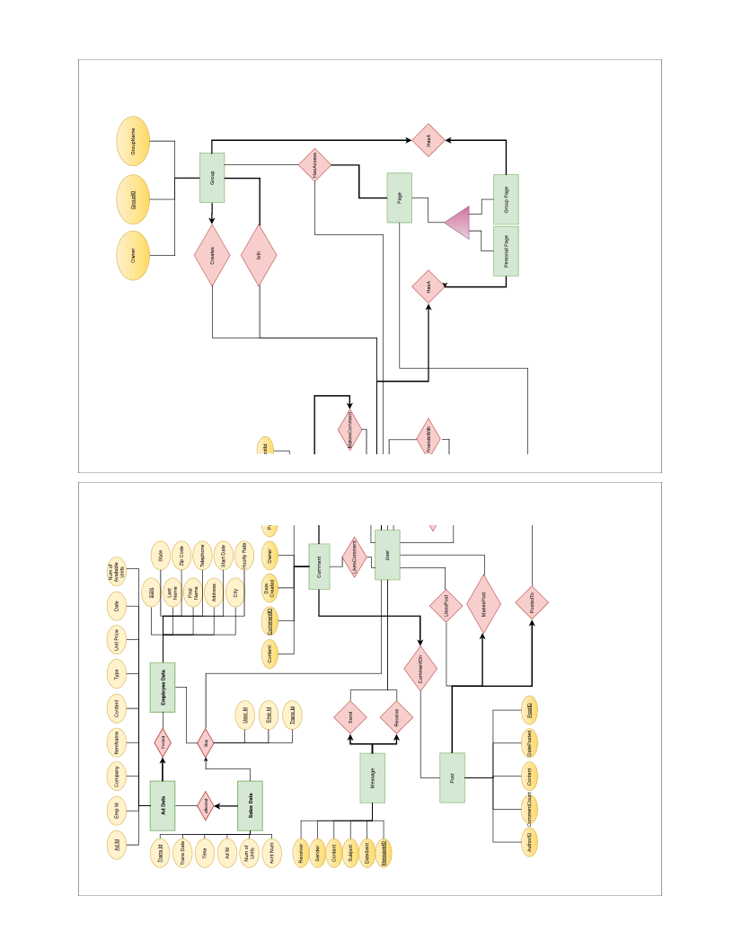Phase 1**

**Rationale**

* User
  + A user is someone who will be using this social media service. When they signup, they input some personal information and that along with a UserID will be added as a row to the User table.
  + A User can connect with multiple (0..*) people.
  + A User can be connected with multiple (0..*) people.
  + A User can create multiple (0..*) groups.
* Group
  + Group needs to be created by exactly one (1) person.
  + A User is in multiple (0..*) groups.
  + A group is composed of at least one (1..*) person.
* Post
  + A user can make multiple (0..*) posts.
  + A post is made by exactly one (1) person.
  + A post can have multiple (0..*) comments.
* Comment
  + A user can make multiple (0..*) comments.
  + A comment is made by exactly one (1) person.
  + A comment is on exactly one (1) post.
* Likes
  + A user can like multiple (0..*) posts.
  + A post can be liked by multiple (0..*) people.
  + A user can like multiple (0..*) comments.
  + A comment can be liked by multiple (0..*) people.
* Page
  + A User has a personal page while a group has a group page.
  + A post is posted to exactly one (1) page.
  + A page has multiple (0..*) posts.
  + A group page can be viewed by all the members of the group while the personal page can be viewed by all users.
* Message
  + A User can message another user.
  + There is only one sender and receiver to a message.
* Advertisement
  + An employee has to post ad data.
  + Ad data has to be posted by exactly one employee.
  + An employee manages sale of products by users.
  + If a user clicked on an ad data that was posted by an employee and buys something through that ad, that employee oversees the transaction.
  + Sales data is the information acquired from a user buying a product or a service because of an ad that was posted by an employee.
  + A User can buy many things but a specific sale can only be made once by one user.

**Relational Model**

CREATE TABLE UserPlus (

UserId INTEGER AUTO_INCREMENT,

FirstName CHAR(20),

LastName CHAR(20),

Sex CHAR(2),

Email CHAR(50),

Password CHAR(20),

DOB DATE,

Address CHAR(50),

City CHAR(60),

State CHAR(20),

ZipCode INTEGER,

Phone CHAR(10),

Preferences VARCHAR(1000),

AccountCreationDate DATETIME,

CreditCardNum CHAR(16),

AccountNum INTEGER,

PRIMARY KEY (UserId)

);

CREATE TABLE Comment (

CommentId INTEGER AUTO_INCREMENT,

DateCreated DATETIME,

Content VARCHAR(100),

AuthorId INTEGER,

PRIMARY KEY (CommentId),

FOREIGN KEY (AuthorId)

REFERENCES UserPlus (UserId)

);

CREATE TABLE Post (

PostId INTEGER AUTO_INCREMENT,

DateCreated DATETIME,

Content VARCHAR(100),

CommentCount INTEGER,

AuthorId INTEGER,

PRIMARY KEY (PostId),

FOREIGN KEY (AuthorId)

REFERENCES UserPlus (UserId)

);

CREATE TABLE Message (

MessageId INTEGER AUTO_INCREMENT,

DateSent DATETIME,

ReceiverId INTEGER,

SenderId INTEGER,

Subject VARCHAR(100),

Content VARCHAR(100),

PRIMARY KEY (MessageId),

FOREIGN KEY (ReceiverId)

REFERENCES UserPlus (UserId),

FOREIGN KEY (SenderId)

REFERENCES UserPlus (UserId)

);

CREATE TABLE PagePlus (

PageId INTEGER AUTO_INCREMENT,

PostCount INTEGER,

PRIMARY KEY (PageId)

);

CREATE TABLE PersonalPage (

PageId INTEGER AUTO_INCREMENT,

OwnerId INTEGER,

PRIMARY KEY (PageId),

FOREIGN KEY (OwnerId)

REFERENCES UserPlus (UserId)

);

CREATE TABLE GroupPlus (

GroupId INTEGER AUTO_INCREMENT,

GroupName VARCHAR(50),

Owner INTEGER,

Type SET('Club', 'Organization', 'Event', 'News', 'Friends'),

PRIMARY KEY (GroupId),

FOREIGN KEY (Owner)

REFERENCES UserPlus (UserId)

);

CREATE TABLE GroupPage (

PageId INTEGER AUTO_INCREMENT,

GroupId INTEGER,

PRIMARY KEY (PageId),

FOREIGN KEY (GroupId)

REFERENCES GroupPlus (GroupId)

ON UPDATE CASCADE ON DELETE CASCADE

);

-- Jerrel Part

CREATE TABLE FriendsWith (

UserId INTEGER,

FriendId INTEGER,

PRIMARY KEY (UserId , FriendId),

FOREIGN KEY (UserId)

REFERENCES UserPlus (UserId)

ON UPDATE CASCADE ON DELETE NO ACTION,

FOREIGN KEY (FriendId)

REFERENCES UserPlus (UserId)

ON UPDATE CASCADE ON DELETE NO ACTION

);

CREATE TABLE CreatesGroup (

UserId INTEGER,

GroupId INTEGER,

PRIMARY KEY (UserId , GroupId),

FOREIGN KEY (UserId)

REFERENCES UserPlus (UserId)

ON UPDATE CASCADE ON DELETE NO ACTION,

FOREIGN KEY (GroupId)

REFERENCES GroupPlus (GroupId)

ON UPDATE CASCADE ON DELETE CASCADE

);

CREATE TABLE HasAccessToGroup (

UserId INTEGER,

AdderId INTEGER,

PageId INTEGER,

GroupId INTEGER,

PRIMARY KEY (UserId , PageId , GroupId),

FOREIGN KEY (UserId)

REFERENCES UserPlus (UserId)

ON UPDATE CASCADE ON DELETE CASCADE,

FOREIGN KEY (PageId)

REFERENCES PagePlus (PageId)

ON UPDATE CASCADE ON DELETE CASCADE,

FOREIGN KEY (GroupId)

REFERENCES GroupPlus (GroupId)

ON UPDATE CASCADE ON DELETE CASCADE,

FOREIGN KEY (AdderId)

REFERENCES UserPlus (UserId)

ON UPDATE CASCADE ON DELETE CASCADE

);

CREATE TABLE HasAPersonal (

UserId INTEGER,

PersonalPageId INTEGER,

PRIMARY KEY (UserId , PersonalPageId),

FOREIGN KEY (UserId)

REFERENCES UserPlus (UserId)

ON UPDATE CASCADE ON DELETE NO ACTION,

FOREIGN KEY (PersonalPageId)

REFERENCES PersonalPage (PageId)

ON UPDATE CASCADE ON DELETE NO ACTION

);

CREATE TABLE HasAGroupPage (

GroupId INTEGER,

GroupPageId INTEGER,

PRIMARY KEY (GroupId , GroupPageId),

FOREIGN KEY (GroupId)

REFERENCES GroupPlus (GroupId)

ON UPDATE CASCADE ON DELETE CASCADE,

FOREIGN KEY (GroupPageId)

REFERENCES GroupPage (PageId)

ON UPDATE CASCADE ON DELETE CASCADE

);

-- Jane Part

CREATE TABLE LikesComment (

CommentId INTEGER,

UserId INTEGER,

PRIMARY KEY (CommentId , UserId),

FOREIGN KEY (CommentId)

REFERENCES Comment (CommentId)

ON DELETE CASCADE ON UPDATE CASCADE,

FOREIGN KEY (UserId)

REFERENCES UserPlus (UserId)

ON DELETE NO ACTION ON UPDATE CASCADE

);

CREATE TABLE LikesPost (

PostId INTEGER,

UserId INTEGER,

PRIMARY KEY (PostId , UserId),

FOREIGN KEY (PostId)

REFERENCES Post (PostId)

ON DELETE CASCADE ON UPDATE CASCADE,

FOREIGN KEY (UserId)

REFERENCES UserPlus (UserId)

ON DELETE NO ACTION ON UPDATE CASCADE

);

CREATE TABLE PostedTo (

PostId INTEGER,

PageId INTEGER,

PRIMARY KEY (PageId , PostId),

FOREIGN KEY (PageId)

REFERENCES PagePlus (PageId)

ON DELETE NO ACTION ON UPDATE CASCADE,

FOREIGN KEY (PostId)

REFERENCES Post (PostId)

ON DELETE CASCADE ON UPDATE CASCADE

);

CREATE TABLE CommentOn (

CommentId INTEGER,

PostId INTEGER,

PRIMARY KEY (CommentId , PostId),

FOREIGN KEY (CommentId)

REFERENCES Comment (CommentId)

ON DELETE CASCADE ON UPDATE CASCADE,

FOREIGN KEY (PostId)

REFERENCES Post (PostId)

ON DELETE CASCADE ON UPDATE CASCADE

);

CREATE TABLE Employee (

SSN CHAR(11),

LastName CHAR(30),

FirstName CHAR(10),

Address CHAR(50),

City CHAR(60),

State CHAR(20),

ZipCode CHAR(16),

Telephone CHAR(20),

StartDate DATE,

HourlyRate FLOAT,

PRIMARY KEY (SSN)

);

CREATE TABLE AdData (

AdId INTEGER AUTO_INCREMENT,

EmpId CHAR(11) NOT NULL,

Type CHAR(20),

Company CHAR(50),

ItemName CHAR(50),

Content VARCHAR(200),

UnitPrice FLOAT,

NumOfAvaUnits INTEGER,

PRIMARY KEY (AdId),

FOREIGN KEY (EmpId)

REFERENCES Employee (SSN)

ON DELETE NO ACTION ON UPDATE CASCADE

);

CREATE TABLE Sales (

TransId INTEGER AUTO_INCREMENT,

TransDate DATE,

TransTime TIME,

AdId INTEGER,

NumOfUnits INTEGER,

AccountNum INTEGER,

PRIMARY KEY (TransId),

FOREIGN KEY (AdId)

REFERENCES AdData (AdId)

ON DELETE NO ACTION ON UPDATE CASCADE

);

-- create table Posted not necessary, using foreign key relationship between AdData and Employee will be enough

CREATE TABLE Buy (

TransId INTEGER,

EmpId CHAR(11) NOT NULL,

UserId INTEGER,

PRIMARY KEY (TransId , EmpId , UserId),

FOREIGN KEY (TransId)

REFERENCES Sales (TransId)

ON DELETE NO ACTION ON UPDATE CASCADE,

FOREIGN KEY (EmpId)

REFERENCES Employee (SSN)

ON DELETE NO ACTION ON UPDATE CASCADE,

FOREIGN KEY (UserId)

REFERENCES UserPlus (UserId)

ON DELETE NO ACTION ON UPDATE CASCADE

);

CREATE TABLE IsIn (

UserId INTEGER,

GroupId INTEGER,

PRIMARY KEY (UserId , GroupId),

FOREIGN KEY (UserId)

REFERENCES UserPlus (UserId)

ON DELETE NO ACTION ON UPDATE CASCADE,

FOREIGN KEY (GroupId)

REFERENCES GroupPlus (GroupId)

ON DELETE CASCADE ON UPDATE NO ACTION

);

CREATE TABLE Send (

Sender INTEGER,

MessageId INTEGER,

PRIMARY KEY (Sender , MessageId),

FOREIGN KEY (Sender)

REFERENCES UserPlus (UserId)

ON DELETE NO ACTION ON UPDATE CASCADE,

FOREIGN KEY (MessageId)

REFERENCES Message (MessageId)

ON DELETE CASCADE ON UPDATE CASCADE

);

CREATE TABLE Receive (

Receiver INTEGER,

MessageId INTEGER,

PRIMARY KEY (Receiver , MessageId),

FOREIGN KEY (Receiver)

REFERENCES UserPlus (UserId)

ON DELETE NO ACTION ON UPDATE CASCADE,

FOREIGN KEY (MessageId)

REFERENCES Message (MessageId)

ON DELETE CASCADE ON UPDATE CASCADE

);

**Rationale for Relational Model**

• Posted Relationship: Decided that we don’t need a table for it because every Ad Data has to be posted by one and only one employee.

• Affected Relationship: Decided that we don’t need a table for it because every Sales has to be affected by one and only one ad.

• Creates Relationship: With the same reasons as above, decided to not have the table

• MakesPost Relationship: With the same reasons as above, decided to not have the table

• CommentOn Relationship: With the same reasons as above, decided to not have the table

• HasA Relationship: We added this relationship, to ease the modification of the page owner or reset of the personal pages.

MakesComment, LikesComment, MakesPost, LikesPost, PostedTo, and CommentsOn are all represented in the schema because they all have one-to-many or many-to-many relationships. To check that a comment that is being liked is a comment that already exists, there is an assertion named comment exists. To check that a post that is being liked is a post that already exists, there is an assertion named post exists. To check that when a post is made that post is posted on the page, there is an assertion named post is posted. To check that when a comment is made that comment is posted to the post, there is an assertion named comment is posted. Note: Assertions are commented out to comply with the MySQL.

Buy, IsIn, Send, Receive, FriendsWith, CreatesGroup, HasAccess, HasAPersonal, and HasAGroupPage are all re- lationships that were represented in the schema because they were either many-to-many or one-to-many. An assertion named GroupHaveOwner makes sure that there are no groups without an owner. An assertion named AccessControl makes sure that only users who have made the post are in the HasAccess table. An assertion named NoFriendsWith- Self makes sure that an user cannot be friends with himself/herself. Note: Assertions are commented out to comply with the MySQL.

Note. For logging reasons, every ”ON DELETE” will return ”NO ACTION”.

**II. Phase 2**

**mysqldump w/ Initial data**

-- MySQL dump 10.13 Distrib 5.7.16, for osx10.11 (x86_64)

--

-- Host: localhost Database: Profile

-- ------------------------------------------------------

-- Server version 5.7.16

/*!40101 SET @OLD_CHARACTER_SET_CLIENT=@@CHARACTER_SET_CLIENT */;

/*!40101 SET @OLD_CHARACTER_SET_RESULTS=@@CHARACTER_SET_RESULTS */;

/*!40101 SET @OLD_COLLATION_CONNECTION=@@COLLATION_CONNECTION */;

/*!40101 SET NAMES utf8 */;

/*!40103 SET @OLD_TIME_ZONE=@@TIME_ZONE */;

/*!40103 SET TIME_ZONE='+00:00' */;

/*!40014 SET @OLD_UNIQUE_CHECKS=@@UNIQUE_CHECKS, UNIQUE_CHECKS=0 */;

/*!40014 SET @OLD_FOREIGN_KEY_CHECKS=@@FOREIGN_KEY_CHECKS, FOREIGN_KEY_CHECKS=0 */;

/*!40101 SET @OLD_SQL_MODE=@@SQL_MODE, SQL_MODE='NO_AUTO_VALUE_ON_ZERO' */;

/*!40111 SET @OLD_SQL_NOTES=@@SQL_NOTES, SQL_NOTES=0 */;

--

-- Table structure for table `AdData`

--

DROP TABLE IF EXISTS `AdData`;

/*!40101 SET @saved_cs_client = @@character_set_client */;

/*!40101 SET character_set_client = utf8 */;

CREATE TABLE `AdData` (

`AdId` int(11) NOT NULL AUTO_INCREMENT,

`EmpId` char(11) NOT NULL,

`Type` char(20) DEFAULT NULL,

`Company` char(50) DEFAULT NULL,

`ItemName` char(50) DEFAULT NULL,

`Content` varchar(200) DEFAULT NULL,

`UnitPrice` float DEFAULT NULL,

`NumOfAvaUnits` int(11) DEFAULT NULL,

PRIMARY KEY (`AdId`),

KEY `EmpId` (`EmpId`),

CONSTRAINT `addata_ibfk_1` FOREIGN KEY (`EmpId`) REFERENCES `Employee` (`SSN`) ON DELETE NO ACTION ON UPDATE CASCADE

) ENGINE=InnoDB AUTO_INCREMENT=15 DEFAULT CHARSET=latin1;

/*!40101 SET character_set_client = @saved_cs_client */;

--

-- Dumping data for table `AdData`

--

LOCK TABLES `AdData` WRITE;

/*!40000 ALTER TABLE `AdData` DISABLE KEYS */;

INSERT INTO `AdData` VALUES (1,'153581835','Cars','Google','Google Car','First flying car',100,100),(2,'168375077','Cars','Apple','Apple Car','Second flying car',100000,200),(3,'239251935','Server','Google','Google Server','First AI security server',10,100),(4,'264939771','Etc','Oracle','Oracle AI','See into the future',100000000,1),(5,'269768789','Book','Amazon','Textbook1','First flying book',1000,20),(6,'269768789','Book','Amazon','Textbook2','First diving book',2000,10),(7,'269768789','Cars','Samsung','Samsung TV Car','First 5D TV Car',10000,20),(8,'273874496','Cars','LG','LG Car','First teleport Car',20000,999),(9,'264939771','Shooting','Oracle','Laser Beam','Don\'t do stupid things with it',200000000,1),(10,'269768789','Running','Nike','Luna Glide 4000','First flying shoes',3999,2),(11,'269768789','Running','Amazon','Running Shoes','Make you run',100,10000),(12,'269768789','TV','Samsung','Samsung TV','First 16K TV',100,2),(13,'273874496','Shooting','Gun Maker','AK-47','Just for hunting',200,999),(14,'273874496','Sailing','Sailboat','Nuclear sailboat','Maybe it explodes too',20000,19999);

/*!40000 ALTER TABLE `AdData` ENABLE KEYS */;

UNLOCK TABLES;

--

-- Table structure for table `Buy`

--

DROP TABLE IF EXISTS `Buy`;

/*!40101 SET @saved_cs_client = @@character_set_client */;

/*!40101 SET character_set_client = utf8 */;

CREATE TABLE `Buy` (

`TransId` int(11) NOT NULL,

`EmpId` char(11) NOT NULL,

`UserId` int(11) NOT NULL,

PRIMARY KEY (`TransId`,`EmpId`,`UserId`),

KEY `EmpId` (`EmpId`),

KEY `UserId` (`UserId`),

CONSTRAINT `buy_ibfk_1` FOREIGN KEY (`TransId`) REFERENCES `Sales` (`TransId`) ON DELETE NO ACTION ON UPDATE CASCADE,

CONSTRAINT `buy_ibfk_2` FOREIGN KEY (`EmpId`) REFERENCES `Employee` (`SSN`) ON DELETE NO ACTION ON UPDATE CASCADE,

CONSTRAINT `buy_ibfk_3` FOREIGN KEY (`UserId`) REFERENCES `UserPlus` (`UserId`) ON DELETE NO ACTION ON UPDATE CASCADE

) ENGINE=InnoDB DEFAULT CHARSET=latin1;

/*!40101 SET character_set_client = @saved_cs_client */;

--

-- Dumping data for table `Buy`

--

LOCK TABLES `Buy` WRITE;

/*!40000 ALTER TABLE `Buy` DISABLE KEYS */;

INSERT INTO `Buy` VALUES (1,'153581835',1),(2,'168375077',2),(3,'168375077',3),(4,'264939771',4),(5,'153581835',5),(6,'264939771',6),(7,'153581835',7),(8,'269768789',8),(9,'269768789',9),(10,'269768789',10),(11,'269768789',100001),(19,'269768789',100001),(20,'269768789',100001),(12,'269768789',100002),(13,'269768789',100002),(14,'269768789',100003),(15,'269768789',100003),(16,'269768789',100004),(17,'269768789',100004),(18,'269768789',100005);

/*!40000 ALTER TABLE `Buy` ENABLE KEYS */;

UNLOCK TABLES;

--

-- Table structure for table `Comment`

--

DROP TABLE IF EXISTS `Comment`;

/*!40101 SET @saved_cs_client = @@character_set_client */;

/*!40101 SET character_set_client = utf8 */;

CREATE TABLE `Comment` (

`CommentId` int(11) NOT NULL AUTO_INCREMENT,

`DateCreated` datetime DEFAULT NULL,

`Content` varchar(100) DEFAULT NULL,

`AuthorId` int(11) DEFAULT NULL,

PRIMARY KEY (`CommentId`),

KEY `AuthorId` (`AuthorId`),

CONSTRAINT `comment_ibfk_1` FOREIGN KEY (`AuthorId`) REFERENCES `UserPlus` (`UserId`)

) ENGINE=InnoDB AUTO_INCREMENT=26 DEFAULT CHARSET=latin1;

/*!40101 SET character_set_client = @saved_cs_client */;

--

-- Dumping data for table `Comment`

--

LOCK TABLES `Comment` WRITE;

/*!40000 ALTER TABLE `Comment` DISABLE KEYS */;

INSERT INTO `Comment` VALUES (1,'2016-12-09 15:10:56','2',1),(2,'2016-12-09 15:10:56','3',2),(3,'2016-12-09 15:10:56','4',3),(4,'2016-12-09 15:10:56','5',4),(5,'2016-12-09 15:10:56','6',5),(6,'2016-12-09 15:10:56','7',6),(7,'2016-12-09 15:10:56','8',7),(8,'2016-12-09 15:10:56','9',8),(9,'2016-12-09 15:10:56','10',9),(10,'2016-12-09 15:10:56','11',10),(11,'2016-12-09 15:10:56','12',11),(12,'2016-12-09 15:10:56','13',12),(13,'2016-12-09 15:10:56','14',13),(14,'2016-12-09 15:10:56','15',14),(15,'2016-12-09 15:10:56','16',15),(16,'2016-12-09 15:10:56','17',16),(17,'2016-12-09 15:10:56','18',17),(18,'2016-12-09 15:10:56','19',18),(19,'2016-12-09 15:10:56','20',19),(20,'2016-12-09 15:10:56','21',20),(21,'2016-12-09 15:10:56','22',21),(22,'2016-12-09 15:10:56','23',22),(23,'2016-12-09 15:10:56','24',23),(24,'2016-12-09 15:10:56','25',24),(25,'2016-12-09 15:10:56','1',25);

/*!40000 ALTER TABLE `Comment` ENABLE KEYS */;

UNLOCK TABLES;

--

-- Table structure for table `CommentOn`

--

DROP TABLE IF EXISTS `CommentOn`;

/*!40101 SET @saved_cs_client = @@character_set_client */;

/*!40101 SET character_set_client = utf8 */;

CREATE TABLE `CommentOn` (

`CommentId` int(11) NOT NULL,

`PostId` int(11) NOT NULL,

PRIMARY KEY (`CommentId`,`PostId`),

KEY `PostId` (`PostId`),

CONSTRAINT `commenton_ibfk_1` FOREIGN KEY (`CommentId`) REFERENCES `Comment` (`CommentId`) ON DELETE CASCADE ON UPDATE CASCADE,

CONSTRAINT `commenton_ibfk_2` FOREIGN KEY (`PostId`) REFERENCES `Post` (`PostId`) ON DELETE CASCADE ON UPDATE CASCADE

) ENGINE=InnoDB DEFAULT CHARSET=latin1;

/*!40101 SET character_set_client = @saved_cs_client */;

--

-- Dumping data for table `CommentOn`

--

LOCK TABLES `CommentOn` WRITE;

/*!40000 ALTER TABLE `CommentOn` DISABLE KEYS */;

INSERT INTO `CommentOn` VALUES (1,1),(2,1),(3,1),(4,1),(5,1),(6,1),(7,1),(8,1),(9,1),(10,1),(11,1),(12,1),(13,1),(14,1),(15,1),(16,1),(17,1),(18,1),(19,1),(20,1),(21,1),(22,1),(23,1),(24,1),(25,1);

/*!40000 ALTER TABLE `CommentOn` ENABLE KEYS */;

UNLOCK TABLES;

--

-- Table structure for table `CreatesGroup`

--

DROP TABLE IF EXISTS `CreatesGroup`;

/*!40101 SET @saved_cs_client = @@character_set_client */;

/*!40101 SET character_set_client = utf8 */;

CREATE TABLE `CreatesGroup` (

`UserId` int(11) NOT NULL,

`GroupId` int(11) NOT NULL,

PRIMARY KEY (`UserId`,`GroupId`),

KEY `GroupId` (`GroupId`),

CONSTRAINT `createsgroup_ibfk_1` FOREIGN KEY (`UserId`) REFERENCES `UserPlus` (`UserId`) ON DELETE NO ACTION ON UPDATE CASCADE,

CONSTRAINT `createsgroup_ibfk_2` FOREIGN KEY (`GroupId`) REFERENCES `GroupPlus` (`GroupId`) ON DELETE CASCADE ON UPDATE CASCADE

) ENGINE=InnoDB DEFAULT CHARSET=latin1;

/*!40101 SET character_set_client = @saved_cs_client */;

--

-- Dumping data for table `CreatesGroup`

--

LOCK TABLES `CreatesGroup` WRITE;

/*!40000 ALTER TABLE `CreatesGroup` DISABLE KEYS */;

INSERT INTO `CreatesGroup` VALUES (1,26),(11,26),(2,27),(12,27),(3,28),(14,28),(4,29),(14,29),(5,30),(15,30),(6,31),(7,32),(8,33),(9,34),(10,35);

/*!40000 ALTER TABLE `CreatesGroup` ENABLE KEYS */;

UNLOCK TABLES;

--

-- Table structure for table `Employee`

--

DROP TABLE IF EXISTS `Employee`;

/*!40101 SET @saved_cs_client = @@character_set_client */;

/*!40101 SET character_set_client = utf8 */;

CREATE TABLE `Employee` (

`SSN` char(11) NOT NULL,

`LastName` char(30) DEFAULT NULL,

`FirstName` char(10) DEFAULT NULL,

`Address` char(50) DEFAULT NULL,

`City` char(60) DEFAULT NULL,

`State` char(20) DEFAULT NULL,

`ZipCode` char(16) DEFAULT NULL,

`Telephone` char(20) DEFAULT NULL,

`StartDate` date DEFAULT NULL,

`HourlyRate` float DEFAULT NULL,

PRIMARY KEY (`SSN`)

) ENGINE=InnoDB DEFAULT CHARSET=latin1;

/*!40101 SET character_set_client = @saved_cs_client */;

--

-- Dumping data for table `Employee`

--

LOCK TABLES `Employee` WRITE;

/*!40000 ALTER TABLE `Employee` DISABLE KEYS */;

INSERT INTO `Employee` VALUES ('153581835','Cortez','Azalia','P.O. Box 171, 6263 Vulputate, St.','Essex','Vermont','98163','(594) 213-2948','2016-03-04',40.11),('168375077','Vargas','Ahmed','Ap #913-7885 Aliquam Av.','West Valley City','Utah','80233','(680) 721-9592','2016-10-19',95.97),('239251935','Kline','Stacy','P.O. Box 264, 7449 Sodales St.','St. Petersburg','Florida','44404','(858) 316-1527','2016-12-01',30.68),('264939771','Landry','Dorian','Ap #324-4954 Ad Ave','Baltimore','Maryland','38110','(341) 785-7012','2017-02-26',76.17),('269768789','Nolan','Driscoll','P.O. Box 197, 2598 Lobortis Ave','West Valley City','Utah','24427','(258) 236-5195','2015-11-26',21.44),('273874496','Bond','Xerxes','166-6265 Scelerisque Rd.','Lawton','Oklahoma','61533','(644) 695-3687','2016-02-27',70.92),('285530393','Ware','Karen','510-8225 Est. Ave','Missoula','Montana','98289','(299) 138-5280','2016-11-18',35.56),('319144404','Harrell','Justin','Ap #285-8898 Donec Avenue','Butte','Montana','21088','(431) 359-7765','2017-10-04',86.4),('323455805','Brooks','Brianna','175-183 Suspendisse St.','Jefferson City','Missouri','89105','(113) 485-3017','2017-08-24',43.58),('352369810','Gardner','Neville','P.O. Box 588, 9440 Nullam St.','Cleveland','Ohio','40195','(937) 304-0073','2016-11-10',33.35),('365398046','Hubbard','Aretha','5971 Fusce Rd.','South Bend','Indiana','37591','(702) 386-6800','2017-09-29',71.75),('379548784','Curtis','Octavia','P.O. Box 877, 5076 Elit, Street','Naperville','Illinois','18460','(550) 590-2634','2017-07-26',68.52),('395359320','Russo','Orson','454 Mus. Rd.','Montgomery','Alabama','35310','(474) 147-3496','2017-07-13',62.78),('439086475','Vasquez','Ignatius','537-6243 At St.','Stamford','Connecticut','15700','(317) 724-8680','2017-07-27',26.36),('58971316','Riley','Desiree','270-9361 Lorem Av.','Casper','Wyoming','12432','(402) 756-7169','2015-12-25',27.78),('61029656','Fernandez','Athena','200-8990 Est. Street','Indianapolis','Indiana','89805','(472) 543-8504','2016-03-28',21.61);

/*!40000 ALTER TABLE `Employee` ENABLE KEYS */;

UNLOCK TABLES;

--

-- Table structure for table `FriendsWith`

--

DROP TABLE IF EXISTS `FriendsWith`;

/*!40101 SET @saved_cs_client = @@character_set_client */;

/*!40101 SET character_set_client = utf8 */;

CREATE TABLE `FriendsWith` (

`UserId` int(11) NOT NULL,

`FriendId` int(11) NOT NULL,

PRIMARY KEY (`UserId`,`FriendId`),

KEY `FriendId` (`FriendId`),

CONSTRAINT `friendswith_ibfk_1` FOREIGN KEY (`UserId`) REFERENCES `UserPlus` (`UserId`) ON DELETE NO ACTION ON UPDATE CASCADE,

CONSTRAINT `friendswith_ibfk_2` FOREIGN KEY (`FriendId`) REFERENCES `UserPlus` (`UserId`) ON DELETE NO ACTION ON UPDATE CASCADE

) ENGINE=InnoDB DEFAULT CHARSET=latin1;

/*!40101 SET character_set_client = @saved_cs_client */;

--

-- Dumping data for table `FriendsWith`

--

LOCK TABLES `FriendsWith` WRITE;

/*!40000 ALTER TABLE `FriendsWith` DISABLE KEYS */;

INSERT INTO `FriendsWith` VALUES (2,1),(3,1),(20,1),(25,1),(1,2),(1,3),(6,4),(4,6),(25,10),(1,20),(1,25),(10,25);

/*!40000 ALTER TABLE `FriendsWith` ENABLE KEYS */;

UNLOCK TABLES;

--

-- Table structure for table `GroupPage`

--

DROP TABLE IF EXISTS `GroupPage`;

/*!40101 SET @saved_cs_client = @@character_set_client */;

/*!40101 SET character_set_client = utf8 */;

CREATE TABLE `GroupPage` (

`PageId` int(11) NOT NULL AUTO_INCREMENT,

`GroupId` int(11) DEFAULT NULL,

PRIMARY KEY (`PageId`),

KEY `GroupId` (`GroupId`),

CONSTRAINT `grouppage_ibfk_1` FOREIGN KEY (`GroupId`) REFERENCES `GroupPlus` (`GroupId`) ON DELETE CASCADE ON UPDATE CASCADE

) ENGINE=InnoDB AUTO_INCREMENT=200007 DEFAULT CHARSET=latin1;

/*!40101 SET character_set_client = @saved_cs_client */;

--

-- Dumping data for table `GroupPage`

--

LOCK TABLES `GroupPage` WRITE;

/*!40000 ALTER TABLE `GroupPage` DISABLE KEYS */;

INSERT INTO `GroupPage` VALUES (26,26),(27,27),(28,28),(29,29),(30,30),(31,31),(32,32),(33,33),(34,34),(35,35),(200001,200001),(200002,200002),(200003,200003),(200004,200004),(200005,200005),(200006,200006);

/*!40000 ALTER TABLE `GroupPage` ENABLE KEYS */;

UNLOCK TABLES;

--

-- Table structure for table `GroupPlus`

--

DROP TABLE IF EXISTS `GroupPlus`;

/*!40101 SET @saved_cs_client = @@character_set_client */;

/*!40101 SET character_set_client = utf8 */;

CREATE TABLE `GroupPlus` (

`GroupId` int(11) NOT NULL AUTO_INCREMENT,

`GroupName` varchar(50) DEFAULT NULL,

`Owner` int(11) DEFAULT NULL,

`Type` set('Club','Organization','Event','News','Friends') DEFAULT NULL,

PRIMARY KEY (`GroupId`),

KEY `Owner` (`Owner`),

CONSTRAINT `groupplus_ibfk_1` FOREIGN KEY (`Owner`) REFERENCES `UserPlus` (`UserId`)

) ENGINE=InnoDB AUTO_INCREMENT=200007 DEFAULT CHARSET=latin1;

/*!40101 SET character_set_client = @saved_cs_client */;

--

-- Dumping data for table `GroupPlus`

--

LOCK TABLES `GroupPlus` WRITE;

/*!40000 ALTER TABLE `GroupPlus` DISABLE KEYS */;

INSERT INTO `GroupPlus` VALUES (26,'Automated value-added process improvement',1,NULL),(27,'Diverse next generation knowledge base',2,NULL),(28,'Inverse contextually-based forecast',3,NULL),(29,'Team-oriented contextually-based solution',4,NULL),(30,'Enterprise-wide encompassing portal',5,NULL),(31,'Event',6,NULL),(32,'Event',7,NULL),(33,'Event',8,NULL),(34,'Event',9,NULL),(35,'Event',10,NULL),(200001,'My Friends',100001,'Friends'),(200002,'Best Friends',100002,'Friends'),(200003,'StonyBrookGang',100003,'Friends'),(200004,'CS Folks',100004,'Friends'),(200005,'My Family',100005,'Friends'),(200006,'Microsoft Groupies',100006,'Friends');

/*!40000 ALTER TABLE `GroupPlus` ENABLE KEYS */;

UNLOCK TABLES;

--

-- Table structure for table `HasAGroupPage`

--

DROP TABLE IF EXISTS `HasAGroupPage`;

/*!40101 SET @saved_cs_client = @@character_set_client */;

/*!40101 SET character_set_client = utf8 */;

CREATE TABLE `HasAGroupPage` (

`GroupId` int(11) NOT NULL,

`GroupPageId` int(11) NOT NULL,

PRIMARY KEY (`GroupId`,`GroupPageId`),

KEY `GroupPageId` (`GroupPageId`),

CONSTRAINT `hasagrouppage_ibfk_1` FOREIGN KEY (`GroupId`) REFERENCES `GroupPlus` (`GroupId`) ON DELETE CASCADE ON UPDATE CASCADE,

CONSTRAINT `hasagrouppage_ibfk_2` FOREIGN KEY (`GroupPageId`) REFERENCES `GroupPage` (`PageId`) ON DELETE CASCADE ON UPDATE CASCADE

) ENGINE=InnoDB DEFAULT CHARSET=latin1;

/*!40101 SET character_set_client = @saved_cs_client */;

--

-- Dumping data for table `HasAGroupPage`

--

LOCK TABLES `HasAGroupPage` WRITE;

/*!40000 ALTER TABLE `HasAGroupPage` DISABLE KEYS */;

INSERT INTO `HasAGroupPage` VALUES (26,26),(27,27),(28,28),(29,29),(30,30),(31,31),(32,32),(33,33),(34,34),(35,35);

/*!40000 ALTER TABLE `HasAGroupPage` ENABLE KEYS */;

UNLOCK TABLES;

--

-- Table structure for table `HasAPersonal`

--

DROP TABLE IF EXISTS `HasAPersonal`;

/*!40101 SET @saved_cs_client = @@character_set_client */;

/*!40101 SET character_set_client = utf8 */;

CREATE TABLE `HasAPersonal` (

`UserId` int(11) NOT NULL,

`PersonalPageId` int(11) NOT NULL,

PRIMARY KEY (`UserId`,`PersonalPageId`),

KEY `PersonalPageId` (`PersonalPageId`),

CONSTRAINT `hasapersonal_ibfk_1` FOREIGN KEY (`UserId`) REFERENCES `UserPlus` (`UserId`) ON DELETE NO ACTION ON UPDATE CASCADE,

CONSTRAINT `hasapersonal_ibfk_2` FOREIGN KEY (`PersonalPageId`) REFERENCES `PersonalPage` (`PageId`) ON DELETE NO ACTION ON UPDATE CASCADE

) ENGINE=InnoDB DEFAULT CHARSET=latin1;

/*!40101 SET character_set_client = @saved_cs_client */;

--

-- Dumping data for table `HasAPersonal`

--

LOCK TABLES `HasAPersonal` WRITE;

/*!40000 ALTER TABLE `HasAPersonal` DISABLE KEYS */;

INSERT INTO `HasAPersonal` VALUES (1,1),(2,2),(3,3),(4,4),(5,5),(6,6),(7,7),(8,8),(9,9),(10,10),(11,11),(12,12),(13,13),(14,14),(15,15),(16,16),(17,17),(18,18),(19,19),(20,20),(21,21),(22,22),(23,23),(24,24),(25,25);

/*!40000 ALTER TABLE `HasAPersonal` ENABLE KEYS */;

UNLOCK TABLES;

--

-- Table structure for table `HasAccessToGroup`

--

DROP TABLE IF EXISTS `HasAccessToGroup`;

/*!40101 SET @saved_cs_client = @@character_set_client */;

/*!40101 SET character_set_client = utf8 */;

CREATE TABLE `HasAccessToGroup` (

`UserId` int(11) NOT NULL,

`AdderId` int(11) DEFAULT NULL,

`PageId` int(11) NOT NULL,

`GroupId` int(11) NOT NULL,

PRIMARY KEY (`UserId`,`PageId`,`GroupId`),

KEY `PageId` (`PageId`),

KEY `GroupId` (`GroupId`),

KEY `AdderId` (`AdderId`),

CONSTRAINT `hasaccesstogroup_ibfk_1` FOREIGN KEY (`UserId`) REFERENCES `UserPlus` (`UserId`) ON DELETE CASCADE ON UPDATE CASCADE,

CONSTRAINT `hasaccesstogroup_ibfk_2` FOREIGN KEY (`PageId`) REFERENCES `PagePlus` (`PageId`) ON DELETE CASCADE ON UPDATE CASCADE,

CONSTRAINT `hasaccesstogroup_ibfk_3` FOREIGN KEY (`GroupId`) REFERENCES `GroupPlus` (`GroupId`) ON DELETE CASCADE ON UPDATE CASCADE,

CONSTRAINT `hasaccesstogroup_ibfk_4` FOREIGN KEY (`AdderId`) REFERENCES `UserPlus` (`UserId`) ON DELETE CASCADE ON UPDATE CASCADE

) ENGINE=InnoDB DEFAULT CHARSET=latin1;

/*!40101 SET character_set_client = @saved_cs_client */;

--

-- Dumping data for table `HasAccessToGroup`

--

LOCK TABLES `HasAccessToGroup` WRITE;

/*!40000 ALTER TABLE `HasAccessToGroup` DISABLE KEYS */;

INSERT INTO `HasAccessToGroup` VALUES (1,NULL,26,26),(2,NULL,27,27),(3,NULL,28,28),(4,NULL,29,29),(5,NULL,30,30),(6,NULL,31,31),(7,NULL,32,32),(8,NULL,33,33),(9,NULL,34,34),(10,NULL,35,35),(11,1,26,26),(12,2,27,27),(14,3,28,28),(14,4,29,29),(15,5,30,30);

/*!40000 ALTER TABLE `HasAccessToGroup` ENABLE KEYS */;

UNLOCK TABLES;

--

-- Table structure for table `IsIn`

--

DROP TABLE IF EXISTS `IsIn`;

/*!40101 SET @saved_cs_client = @@character_set_client */;

/*!40101 SET character_set_client = utf8 */;

CREATE TABLE `IsIn` (

`UserId` int(11) NOT NULL,

`GroupId` int(11) NOT NULL,

PRIMARY KEY (`UserId`,`GroupId`),

KEY `GroupId` (`GroupId`),

CONSTRAINT `isin_ibfk_1` FOREIGN KEY (`UserId`) REFERENCES `UserPlus` (`UserId`) ON DELETE NO ACTION ON UPDATE CASCADE,

CONSTRAINT `isin_ibfk_2` FOREIGN KEY (`GroupId`) REFERENCES `GroupPlus` (`GroupId`) ON DELETE CASCADE ON UPDATE NO ACTION

) ENGINE=InnoDB DEFAULT CHARSET=latin1;

/*!40101 SET character_set_client = @saved_cs_client */;

--

-- Dumping data for table `IsIn`

--

LOCK TABLES `IsIn` WRITE;

/*!40000 ALTER TABLE `IsIn` DISABLE KEYS */;

INSERT INTO `IsIn` VALUES (1,26),(2,26),(3,26),(4,26),(5,26),(6,26),(2,27),(3,28),(4,29),(5,30),(6,31),(7,32),(8,33),(9,34),(10,35);

/*!40000 ALTER TABLE `IsIn` ENABLE KEYS */;

UNLOCK TABLES;

--

-- Table structure for table `LikesComment`

--

DROP TABLE IF EXISTS `LikesComment`;

/*!40101 SET @saved_cs_client = @@character_set_client */;

/*!40101 SET character_set_client = utf8 */;

CREATE TABLE `LikesComment` (

`CommentId` int(11) NOT NULL,

`UserId` int(11) NOT NULL,

PRIMARY KEY (`CommentId`,`UserId`),

KEY `UserId` (`UserId`),

CONSTRAINT `likescomment_ibfk_1` FOREIGN KEY (`CommentId`) REFERENCES `Comment` (`CommentId`) ON DELETE CASCADE ON UPDATE CASCADE,

CONSTRAINT `likescomment_ibfk_2` FOREIGN KEY (`UserId`) REFERENCES `UserPlus` (`UserId`) ON DELETE NO ACTION ON UPDATE CASCADE

) ENGINE=InnoDB DEFAULT CHARSET=latin1;

/*!40101 SET character_set_client = @saved_cs_client */;

--

-- Dumping data for table `LikesComment`

--

LOCK TABLES `LikesComment` WRITE;

/*!40000 ALTER TABLE `LikesComment` DISABLE KEYS */;

INSERT INTO `LikesComment` VALUES (1,1),(1,2),(1,3),(1,4),(1,5),(1,6),(1,7),(1,8),(1,9),(1,10),(1,11),(1,12),(1,13),(1,14),(1,15),(1,16),(1,17),(1,18),(1,19),(1,20),(1,21),(1,22),(1,23),(1,24),(1,25);

/*!40000 ALTER TABLE `LikesComment` ENABLE KEYS */;

UNLOCK TABLES;

--

-- Table structure for table `LikesPost`

--

DROP TABLE IF EXISTS `LikesPost`;

/*!40101 SET @saved_cs_client = @@character_set_client */;

/*!40101 SET character_set_client = utf8 */;

CREATE TABLE `LikesPost` (

`PostId` int(11) NOT NULL,

`UserId` int(11) NOT NULL,

PRIMARY KEY (`PostId`,`UserId`),

KEY `UserId` (`UserId`),

CONSTRAINT `likespost_ibfk_1` FOREIGN KEY (`PostId`) REFERENCES `Post` (`PostId`) ON DELETE CASCADE ON UPDATE CASCADE,

CONSTRAINT `likespost_ibfk_2` FOREIGN KEY (`UserId`) REFERENCES `UserPlus` (`UserId`) ON DELETE NO ACTION ON UPDATE CASCADE

) ENGINE=InnoDB DEFAULT CHARSET=latin1;

/*!40101 SET character_set_client = @saved_cs_client */;

--

-- Dumping data for table `LikesPost`

--

LOCK TABLES `LikesPost` WRITE;

/*!40000 ALTER TABLE `LikesPost` DISABLE KEYS */;

INSERT INTO `LikesPost` VALUES (1,1),(1,2),(1,3),(1,4),(1,5),(1,6),(1,7),(1,8),(1,9),(1,10),(1,11),(1,12),(1,13),(1,14),(1,15),(1,16),(1,17),(1,18),(1,19),(1,20),(1,21),(1,22),(1,23),(1,24),(1,25);

/*!40000 ALTER TABLE `LikesPost` ENABLE KEYS */;

UNLOCK TABLES;

--

-- Table structure for table `Message`

--

DROP TABLE IF EXISTS `Message`;

/*!40101 SET @saved_cs_client = @@character_set_client */;

/*!40101 SET character_set_client = utf8 */;

CREATE TABLE `Message` (

`MessageId` int(11) NOT NULL AUTO_INCREMENT,

`DateSent` datetime DEFAULT NULL,

`ReceiverId` int(11) DEFAULT NULL,

`SenderId` int(11) DEFAULT NULL,

`Subject` varchar(100) DEFAULT NULL,

`Content` varchar(100) DEFAULT NULL,

PRIMARY KEY (`MessageId`),

KEY `ReceiverId` (`ReceiverId`),

KEY `SenderId` (`SenderId`),

CONSTRAINT `message_ibfk_1` FOREIGN KEY (`ReceiverId`) REFERENCES `UserPlus` (`UserId`),

CONSTRAINT `message_ibfk_2` FOREIGN KEY (`SenderId`) REFERENCES `UserPlus` (`UserId`)

) ENGINE=InnoDB AUTO_INCREMENT=26 DEFAULT CHARSET=latin1;

/*!40101 SET character_set_client = @saved_cs_client */;

--

-- Dumping data for table `Message`

--

LOCK TABLES `Message` WRITE;

/*!40000 ALTER TABLE `Message` DISABLE KEYS */;

INSERT INTO `Message` VALUES (1,'2016-12-09 15:10:56',2,1,'subject','apples'),(2,'2016-12-09 15:10:56',3,2,'subject','one'),(3,'2016-12-09 15:10:56',4,3,'subject','q'),(4,'2016-12-09 15:10:56',5,4,'subject','e'),(5,'2016-12-09 15:10:56',6,5,'subject','y'),(6,'2016-12-09 15:10:56',7,6,'subject','er'),(7,'2016-12-09 15:10:56',8,7,'subject','dsgdfg'),(8,'2016-12-09 15:10:56',9,8,'subject','yetikty'),(9,'2016-12-09 15:10:56',10,9,'subject','raehuy56h46'),(10,'2016-12-09 15:10:56',11,10,'subject','rstj7e5jurt'),(11,'2016-12-09 15:10:56',12,11,'subject','jrtwjety6j'),(12,'2016-12-09 15:10:56',13,12,'subject','tyjrstyjkrsty'),(13,'2016-12-09 15:10:56',14,13,'subject','jkmrastyjsrthjurt6h'),(14,'2016-12-09 15:10:56',15,14,'subject','rthuertyjrstwjrtyjrtyu'),(15,'2016-12-09 15:10:56',16,15,'subject','rt6h'),(16,'2016-12-09 15:10:56',17,16,'subject','56hurty6u46h'),(17,'2016-12-09 15:10:56',18,17,'subject','56hjnrt'),(18,'2016-12-09 15:10:56',19,18,'subject','jursyhju'),(19,'2016-12-09 15:10:56',20,19,'subject','rs6tjhdty6jrstj'),(20,'2016-12-09 15:10:56',21,20,'subject','srtyjdty'),(21,'2016-12-09 15:10:56',22,21,'subject','jrs6hj'),(22,'2016-12-09 15:10:56',23,22,'subject','rs6thj'),(23,'2016-12-09 15:10:56',24,23,'subject','htyj'),(24,'2016-12-09 15:10:56',25,24,'subject','tyje57tyjtyjty'),(25,'2016-12-09 15:10:56',1,25,'subject','jrj6');

/*!40000 ALTER TABLE `Message` ENABLE KEYS */;

UNLOCK TABLES;

--

-- Table structure for table `PagePlus`

--

DROP TABLE IF EXISTS `PagePlus`;

/*!40101 SET @saved_cs_client = @@character_set_client */;

/*!40101 SET character_set_client = utf8 */;

CREATE TABLE `PagePlus` (

`PageId` int(11) NOT NULL AUTO_INCREMENT,

`PostCount` int(11) DEFAULT NULL,

PRIMARY KEY (`PageId`)

) ENGINE=InnoDB AUTO_INCREMENT=200007 DEFAULT CHARSET=latin1;

/*!40101 SET character_set_client = @saved_cs_client */;

--

-- Dumping data for table `PagePlus`

--

LOCK TABLES `PagePlus` WRITE;

/*!40000 ALTER TABLE `PagePlus` DISABLE KEYS */;

INSERT INTO `PagePlus` VALUES (1,10),(2,10),(3,5),(4,0),(5,0),(6,0),(7,0),(8,0),(9,0),(10,0),(11,0),(12,0),(13,0),(14,0),(15,0),(16,0),(17,0),(18,0),(19,0),(20,0),(21,0),(22,0),(23,0),(24,0),(25,0),(26,0),(27,0),(28,0),(29,0),(30,0),(31,0),(32,0),(33,0),(34,0),(35,0),(100001,0),(100002,0),(100003,0),(100004,0),(100005,0),(100006,0),(100007,0),(100008,0),(100009,0),(100010,0),(100011,0),(100012,0),(100013,0),(100014,0),(100015,0),(100016,0),(100017,0),(100018,0),(100019,0),(100020,0),(200001,0),(200002,0),(200003,0),(200004,0),(200005,0),(200006,0);

/*!40000 ALTER TABLE `PagePlus` ENABLE KEYS */;

UNLOCK TABLES;

--

-- Table structure for table `PersonalPage`

--

DROP TABLE IF EXISTS `PersonalPage`;

/*!40101 SET @saved_cs_client = @@character_set_client */;

/*!40101 SET character_set_client = utf8 */;

CREATE TABLE `PersonalPage` (

`PageId` int(11) NOT NULL AUTO_INCREMENT,

`OwnerId` int(11) DEFAULT NULL,

PRIMARY KEY (`PageId`),

KEY `OwnerId` (`OwnerId`),

CONSTRAINT `personalpage_ibfk_1` FOREIGN KEY (`OwnerId`) REFERENCES `UserPlus` (`UserId`)

) ENGINE=InnoDB AUTO_INCREMENT=100021 DEFAULT CHARSET=latin1;

/*!40101 SET character_set_client = @saved_cs_client */;

--

-- Dumping data for table `PersonalPage`

--

LOCK TABLES `PersonalPage` WRITE;

/*!40000 ALTER TABLE `PersonalPage` DISABLE KEYS */;

INSERT INTO `PersonalPage` VALUES (1,1),(2,2),(3,3),(4,4),(5,5),(6,6),(7,7),(8,8),(9,9),(10,10),(11,11),(12,12),(13,13),(14,14),(15,15),(16,16),(17,17),(18,18),(19,19),(20,20),(21,21),(22,22),(23,23),(24,24),(25,25),(100001,100001),(100002,100002),(100003,100003),(100004,100004),(100005,100005),(100006,100006),(100007,100007),(100008,100008),(100009,100009),(100010,100010),(100011,100011),(100012,100012),(100013,100013),(100014,100014),(100015,100015),(100016,100016),(100017,100017),(100018,100018),(100019,100019),(100020,100020);

/*!40000 ALTER TABLE `PersonalPage` ENABLE KEYS */;

UNLOCK TABLES;

--

-- Table structure for table `Post`

--

DROP TABLE IF EXISTS `Post`;

/*!40101 SET @saved_cs_client = @@character_set_client */;

/*!40101 SET character_set_client = utf8 */;

CREATE TABLE `Post` (

`PostId` int(11) NOT NULL AUTO_INCREMENT,

`DateCreated` datetime DEFAULT NULL,

`Content` varchar(100) DEFAULT NULL,

`CommentCount` int(11) DEFAULT NULL,

`AuthorId` int(11) DEFAULT NULL,

PRIMARY KEY (`PostId`),

KEY `AuthorId` (`AuthorId`),

CONSTRAINT `post_ibfk_1` FOREIGN KEY (`AuthorId`) REFERENCES `UserPlus` (`UserId`)

) ENGINE=InnoDB AUTO_INCREMENT=21 DEFAULT CHARSET=latin1;

/*!40101 SET character_set_client = @saved_cs_client */;

--

-- Dumping data for table `Post`

--

LOCK TABLES `Post` WRITE;

/*!40000 ALTER TABLE `Post` DISABLE KEYS */;

INSERT INTO `Post` VALUES (1,'2016-12-09 15:10:56','envisioneer frictionless deliverables',10,1),(2,'2016-12-09 15:10:56','engineer back-end paradigms',0,2),(3,'2016-12-09 15:10:56','redefine efficient infrastructures',0,3),(4,'2016-12-09 15:10:56','embrace sticky experiences',0,4),(5,'2016-12-09 15:10:56','synthesize innovative niches',0,5),(6,'2016-12-09 15:10:56','engage compelling methodologies',0,6),(7,'2016-12-09 15:10:56','exploit dot-com platforms',0,7),(8,'2016-12-09 15:10:56','benchmark seamless portals',0,8),(9,'2016-12-09 15:10:56','utilize leading-edge networks',0,9),(10,'2016-12-09 15:10:56','generate collaborative interfaces',0,10),(11,'2016-12-09 15:10:56','visualize bleeding-edge mindshare',0,11),(12,'2016-12-09 15:10:56','drive virtual initiatives',0,12),(13,'2016-12-09 15:10:56','empower cutting-edge portals',0,13),(14,'2016-12-09 15:10:56','mesh revolutionary networks',0,14),(15,'2016-12-09 15:10:56','mesh granular metrics',0,15),(16,'2016-12-09 15:10:56','incentivize transparent ROI',0,16),(17,'2016-12-09 15:10:56','iterate back-end deliverables',0,17),(18,'2016-12-09 15:10:56','generate dynamic web services',0,18),(19,'2016-12-09 15:10:56','transform visionary eyeballs',0,19),(20,'2016-12-09 15:10:56','architect dot-com e-services',0,20);

/*!40000 ALTER TABLE `Post` ENABLE KEYS */;

UNLOCK TABLES;

--

-- Table structure for table `PostedTo`

--

DROP TABLE IF EXISTS `PostedTo`;

/*!40101 SET @saved_cs_client = @@character_set_client */;

/*!40101 SET character_set_client = utf8 */;

CREATE TABLE `PostedTo` (

`PostId` int(11) NOT NULL,

`PageId` int(11) NOT NULL,

PRIMARY KEY (`PageId`,`PostId`),

KEY `PostId` (`PostId`),

CONSTRAINT `postedto_ibfk_1` FOREIGN KEY (`PageId`) REFERENCES `PagePlus` (`PageId`) ON DELETE NO ACTION ON UPDATE CASCADE,

CONSTRAINT `postedto_ibfk_2` FOREIGN KEY (`PostId`) REFERENCES `Post` (`PostId`) ON DELETE CASCADE ON UPDATE CASCADE

) ENGINE=InnoDB DEFAULT CHARSET=latin1;

/*!40101 SET character_set_client = @saved_cs_client */;

--

-- Dumping data for table `PostedTo`

--

LOCK TABLES `PostedTo` WRITE;

/*!40000 ALTER TABLE `PostedTo` DISABLE KEYS */;

INSERT INTO `PostedTo` VALUES (1,1),(2,1),(3,1),(4,1),(5,1),(6,1),(7,1),(8,1),(9,1),(10,1),(11,1),(12,1),(13,1),(14,1),(15,1),(16,1),(17,1),(18,1),(19,1),(20,1);

/*!40000 ALTER TABLE `PostedTo` ENABLE KEYS */;

UNLOCK TABLES;

--

-- Table structure for table `Receive`

--

DROP TABLE IF EXISTS `Receive`;

/*!40101 SET @saved_cs_client = @@character_set_client */;

/*!40101 SET character_set_client = utf8 */;

CREATE TABLE `Receive` (

`Receiver` int(11) NOT NULL,

`MessageId` int(11) NOT NULL,

PRIMARY KEY (`Receiver`,`MessageId`),

KEY `MessageId` (`MessageId`),

CONSTRAINT `receive_ibfk_1` FOREIGN KEY (`Receiver`) REFERENCES `UserPlus` (`UserId`) ON DELETE NO ACTION ON UPDATE CASCADE,

CONSTRAINT `receive_ibfk_2` FOREIGN KEY (`MessageId`) REFERENCES `Message` (`MessageId`) ON DELETE CASCADE ON UPDATE CASCADE

) ENGINE=InnoDB DEFAULT CHARSET=latin1;

/*!40101 SET character_set_client = @saved_cs_client */;

--

-- Dumping data for table `Receive`

--

LOCK TABLES `Receive` WRITE;

/*!40000 ALTER TABLE `Receive` DISABLE KEYS */;

INSERT INTO `Receive` VALUES (2,1),(3,2),(4,3),(5,4),(6,5),(7,6),(8,7),(9,8),(10,9),(11,10),(12,11),(13,12),(14,13),(15,14),(16,15),(17,16),(18,17),(19,18),(20,19),(21,20),(22,21),(23,22),(24,23),(25,24);

/*!40000 ALTER TABLE `Receive` ENABLE KEYS */;

UNLOCK TABLES;

--

-- Table structure for table `Sales`

--

DROP TABLE IF EXISTS `Sales`;

/*!40101 SET @saved_cs_client = @@character_set_client */;

/*!40101 SET character_set_client = utf8 */;

CREATE TABLE `Sales` (

`TransId` int(11) NOT NULL AUTO_INCREMENT,

`TransDate` date DEFAULT NULL,

`TransTime` time DEFAULT NULL,

`AdId` int(11) DEFAULT NULL,

`NumOfUnits` int(11) DEFAULT NULL,

`AccountNum` int(11) DEFAULT NULL,

PRIMARY KEY (`TransId`),

KEY `AdId` (`AdId`),

CONSTRAINT `sales_ibfk_1` FOREIGN KEY (`AdId`) REFERENCES `AdData` (`AdId`) ON DELETE NO ACTION ON UPDATE CASCADE

) ENGINE=InnoDB AUTO_INCREMENT=21 DEFAULT CHARSET=latin1;

/*!40101 SET character_set_client = @saved_cs_client */;

--

-- Dumping data for table `Sales`

--

LOCK TABLES `Sales` WRITE;

/*!40000 ALTER TABLE `Sales` DISABLE KEYS */;

INSERT INTO `Sales` VALUES (1,'2016-10-01','11:10:00',1,100,12341234),(2,'2016-10-02','11:10:00',2,10,11111111),(3,'2016-10-03','11:10:00',3,1,22222222),(4,'2016-11-03','11:10:00',3,1,33333333),(5,'2015-09-03','11:10:00',4,1,22222222),(6,'2016-10-03','11:10:00',5,19,222333333),(7,'2012-07-03','11:10:00',9,1,12342222),(8,'2011-10-23','11:10:00',9,1,12341111),(9,'2016-01-13','11:10:00',3,1,4321222),(10,'2012-06-03','11:10:00',10,1,33333333),(11,'2016-10-01','12:10:00',11,100,900001),(12,'2016-10-02','11:15:00',12,10,900002),(13,'2016-10-03','11:17:00',13,1,900002),(14,'2016-11-03','10:10:00',13,1,900003),(15,'2015-09-03','11:10:00',14,1,900003),(16,'2016-10-03','11:32:00',7,19,900004),(17,'2012-07-03','10:10:00',11,1,900004),(18,'2011-10-23','12:10:00',12,1,900005),(19,'2016-01-13','11:11:00',13,1,900001),(20,'2012-06-03','11:10:00',13,1,900001);

/*!40000 ALTER TABLE `Sales` ENABLE KEYS */;

UNLOCK TABLES;

--

-- Table structure for table `Send`

--

DROP TABLE IF EXISTS `Send`;

/*!40101 SET @saved_cs_client = @@character_set_client */;

/*!40101 SET character_set_client = utf8 */;

CREATE TABLE `Send` (

`Sender` int(11) NOT NULL,

`MessageId` int(11) NOT NULL,

PRIMARY KEY (`Sender`,`MessageId`),

KEY `MessageId` (`MessageId`),

CONSTRAINT `send_ibfk_1` FOREIGN KEY (`Sender`) REFERENCES `UserPlus` (`UserId`) ON DELETE NO ACTION ON UPDATE CASCADE,

CONSTRAINT `send_ibfk_2` FOREIGN KEY (`MessageId`) REFERENCES `Message` (`MessageId`) ON DELETE CASCADE ON UPDATE CASCADE

) ENGINE=InnoDB DEFAULT CHARSET=latin1;

/*!40101 SET character_set_client = @saved_cs_client */;

--

-- Dumping data for table `Send`

--

LOCK TABLES `Send` WRITE;

/*!40000 ALTER TABLE `Send` DISABLE KEYS */;

INSERT INTO `Send` VALUES (1,1),(2,2),(3,3),(4,4),(5,5),(6,6),(7,7),(8,8),(9,9),(10,10),(11,11),(12,12),(13,13),(14,14),(15,15),(16,16),(17,17),(18,18),(19,19),(20,20),(21,21),(22,22),(23,23),(24,24);

/*!40000 ALTER TABLE `Send` ENABLE KEYS */;

UNLOCK TABLES;

--

-- Table structure for table `UserPlus`

--

DROP TABLE IF EXISTS `UserPlus`;

/*!40101 SET @saved_cs_client = @@character_set_client */;

/*!40101 SET character_set_client = utf8 */;

CREATE TABLE `UserPlus` (

`UserId` int(11) NOT NULL AUTO_INCREMENT,

`FirstName` char(20) DEFAULT NULL,

`LastName` char(20) DEFAULT NULL,

`Sex` char(2) DEFAULT NULL,

`Email` char(50) DEFAULT NULL,

`Password` char(20) DEFAULT NULL,

`DOB` date DEFAULT NULL,

`Address` char(50) DEFAULT NULL,

`City` char(60) DEFAULT NULL,

`State` char(20) DEFAULT NULL,

`ZipCode` int(11) DEFAULT NULL,

`Phone` char(10) DEFAULT NULL,

`Preferences` varchar(1000) DEFAULT NULL,

`AccountCreationDate` datetime DEFAULT NULL,

`CreditCardNum` char(16) DEFAULT NULL,

`AccountNum` int(11) DEFAULT NULL,

PRIMARY KEY (`UserId`)

) ENGINE=InnoDB AUTO_INCREMENT=100021 DEFAULT CHARSET=latin1;

/*!40101 SET character_set_client = @saved_cs_client */;

--

-- Dumping data for table `UserPlus`

--

LOCK TABLES `UserPlus` WRITE;

/*!40000 ALTER TABLE `UserPlus` DISABLE KEYS */;

INSERT INTO `UserPlus` VALUES (1,'Michael','Thorne',NULL,'MichaelCThorne@gmail.com','apples',NULL,'4363 Arrowood Drive','Jacksonville','FL',32216,'9044166609','applePicking',NULL,NULL,1),(2,'Paul','Fodor',NULL,'paulfodor@gmail.com','apples',NULL,'2635 Simons Hollow Road','New York','NY',10001,'5707512415','applePicking',NULL,NULL,2),(3,'Michael','Kife',NULL,'MichaelKife@gmail.com','apples',NULL,'885 Augusta Park','Charleston','WV',25301,'9046366609','applePicking',NULL,NULL,3),(4,'Bob','Marvel',NULL,'bobmarvel@gmail.com','apples',NULL,'1 Arrowood Drive','Jacksonville','FL',32216,'9044366619','applePicking',NULL,NULL,4),(5,'yay','grovey',NULL,'yaygrovey@gmail.com','apples',NULL,'342 Arrowood Drive','Jacksonville','FL',32216,'6044366609','applePicking',NULL,NULL,5),(6,'apple','seed',NULL,'appleseed@gmail.com','apples',NULL,'321 Arrowood Drive','Jacksonville','FL',32216,'3044366609','applePicking',NULL,NULL,6),(7,'new','you',NULL,'newyou@gmail.com','apples',NULL,'34 Arrowood Drive','Jacksonville','FL',32216,'9244366609','applePicking',NULL,NULL,7),(8,'qqqq','lol',NULL,'qqqqlol@gmail.com','apples',NULL,'399 Arrowood Drive','Jacksonville','FL',32216,'5044366609','applePicking',NULL,NULL,8),(9,'oop','yo',NULL,'oopyo@gmail.com','apples',NULL,'9 Arrowood Drive','Jacksonville','FL',32216,'9084366609','applePicking',NULL,NULL,9),(10,'one','two',NULL,'onetwo@gmail.com','apples',NULL,'100 Arrowood Drive','Jacksonville','FL',32216,'9047366609','applePicking',NULL,NULL,10),(11,'suretrip','forever',NULL,'suretripforever@gmail.com','apples',NULL,'4363 Arrowood Drive','Jacksonville','FL',32216,'9044386609','applePicking',NULL,NULL,11),(12,'forever','young',NULL,'foreveryoung@gmail.com','apples',NULL,'10101 Arrowood Drive','Jacksonville','FL',32216,'9244366609','applePicking',NULL,NULL,12),(13,'life','video',NULL,'lifevideo@gmail.com','apples',NULL,'3575 Arrowood Drive','Jacksonville','FL',32216,'9044346609','applePicking',NULL,NULL,13),(14,'hit','rewind',NULL,'hitrewind@gmail.com','apples',NULL,'999 Arrowood Drive','Jacksonville','FL',32216,'9044365609','applePicking',NULL,NULL,14),(15,'iwanna','forever',NULL,'iwannaforever@gmail.com','apples',NULL,'11111 Arrowood Drive','Jacksonville','FL',32216,'9044366611','applePicking',NULL,NULL,15),(16,'ayyy','boy',NULL,'ayyyboy@gmail.com','apples',NULL,'777 Arrowood Drive','Jacksonville','FL',32216,'9044311609','applePicking',NULL,NULL,16),(17,'kitchen','stove',NULL,'kitchenstove@gmail.com','apples',NULL,'32232 Arrowood Drive','Jacksonville','FL',32216,'9114366609','applePicking',NULL,NULL,17),(18,'younger','year',NULL,'youngeryear@gmail.com','apples',NULL,'8888 Arrowood Drive','Jacksonville','FL',32216,'9022366609','applePicking',NULL,NULL,18),(19,'applesseed','seedsofapples',NULL,'applesseedseedsofapple@gmail.com','apples',NULL,'1471 Arrowood Drive','Jacksonville','FL',32216,'9045566609','applePicking',NULL,NULL,19),(20,'Michael','Bender',NULL,'MichaelBender@gmail.com','apples',NULL,'4363 Bentley Drive','Jacksonville','FL',32216,'9044666609','applePicking',NULL,NULL,20),(21,'Michael','Tashbook',NULL,'MichaelTashbook@gmail.com','apples',NULL,'4363 Book Drive','Jacksonville','FL',32216,'9010366609','applePicking',NULL,NULL,21),(22,'Richard','Mckenna',NULL,'RichardMckenna@gmail.com','apples',NULL,'4363 Boxman Drive','Jacksonville','FL',32216,'9049166609','applePicking',NULL,NULL,22),(23,'Leo','Backmire',NULL,'LeoBackmire@gmail.com','apples',NULL,'4363 Compsci Drive','Jacksonville','FL',32216,'9082366609','applePicking',NULL,NULL,23),(24,'Moms','Spagetti',NULL,'MomsSpagetti@gmail.com','apples',NULL,'4363 loud Drive','Jacksonville','FL',32216,'8844366609','applePicking',NULL,NULL,24),(25,'Opps','Gravity',NULL,'oppsGravity@gmail.com','apples',NULL,'4363 gravity Drive','Jacksonville','FL',32216,'9044106609','applePicking',NULL,NULL,25),(100001,'Michael','Collins','M','Michael.Collins@cse305.stonybrook.edu','care2cash','1997-03-14','Somewhere','Washington','DC',12345,'228807080','Slacklining,Skateboarding,Surfing,Orienteering,Water_sports',NULL,NULL,900001),(100002,'Aria','Rose','F','Aria.Rose@cse305.stonybrook.edu','dawn4call','1991-05-11','Somewhere','New_York','NY',10001,'263303749','Topiary,Jogging',NULL,NULL,900002),(100003,'Jase','Black','M','Jase.Black@cse305.stonybrook.edu','data6bell','2012-04-26','Somewhere','Washington','DC',12345,'917443776','Rugby,Roller_skating,Life_insurance,Rock_climbing,Scouting',NULL,NULL,900003),(100004,'Ellie','Franklin','F','Ellie.Franklin@cse305.stonybrook.edu','able1cash','2009-03-09','Somewhere','Stony_Brook','NY',11794,'381870672','Cars,Skydiving,Bird_watching,Sailing,Shopping,Skimboarding,Kayaking,Camping,Blacksmithing',NULL,NULL,900004),(100005,'Mackenzie','Wells','F','Mackenzie.Wells@cse305.stonybrook.edu','burn2coat','2004-09-14','Somewhere','NewYork','NY',10001,'736594241','Hunting,Topiary,Nordic_skating,Foraging,Metal_detecting,Camping,Astronomy',NULL,NULL,900005),(100006,'Cameron','Armstrong','M','Cameron.Armstrong@cse305.stonybrook.edu','aged6area','2010-08-14','Somewhere','NewYork','NY',10001,'182209299','Skydiving,Topiary,Scuba_diving,Sailing,Beekeeping,Tai_chi,Brazilian_jiu-jitsu,Astronomy,Jogging',NULL,NULL,900006),(100007,'Levi','Ross','M','Levi.Ross@cse305.stonybrook.edu','been7beer','1991-06-07','Somewhere','StonyBrook','NY',11794,'127536938','Urban_exploration,Freestyle_football',NULL,NULL,900007),(100008,'Levi','West','M','Levi.West@cse305.stonybrook.edu','coal3cell','2011-02-09','Somewhere','NewYork','NY',10001,'699136094','BASE_jumping,Letterboxing,Roller_skating,Metal_detecting,Swimming,Mountaineering,Sculling_or_Rowing,Basketball,Surfing',NULL,NULL,900008),(100009,'Christian','Davies','M','Christian.Davies@cse305.stonybrook.edu','bush1bone','2011-05-10','Somewhere','StonyBrook','NY',11794,'364390765','BASE_jumping,Driving,Mountaineering',NULL,NULL,900009),(100010,'Kylie','Davies','F','Kylie.Davies@cse305.stonybrook.edu','coat7calm','1996-11-22','Somewhere','NewYork','NY',10001,'562348521','Toys,Graffiti,Skiing,Road_biking,Kayaking',NULL,NULL,900010),(100011,'Tyler','Long','M','Tyler.Long@cse305.stonybrook.edu','area3boom','2007-01-08','Somewhere','StonyBrook','NY',11794,'306139234','Topiary,Basketball',NULL,NULL,900011),(100012,'Henry','Stewart','M','Henry.Stewart@cse305.stonybrook.edu','boat3also','2006-02-11','Somewhere','Washington','DC',12345,'503422119','Roller_skating,Netball,Flag_football,Water_sports',NULL,NULL,900012),(100013,'Isaiah','Bennett','M','Isaiah.Bennett@cse305.stonybrook.edu','book6bank','1997-12-24','Somewhere','Washington','DC',12345,'929342276','Walking,Baseball,Scuba_diving,Running,Shopping',NULL,NULL,900013),(100014,'Arianna','Dunn','F','Arianna.Dunn@cse305.stonybrook.edu','chip2calm','2003-01-27','Somewhere','NewYork','NY',10001,'311083148','Shooting,Ghost_hunting,Horseback_riding,Netball,Astronomy',NULL,NULL,900014),(100015,'Victoria','Powell','F','Victoria.Powell@cse305.stonybrook.edu','cash7bush','1997-04-28','Somewhere','NewYork','NY',10001,'854902993','LARPing,Walking,Slacklining,Foraging,Rock_climbing,Taekwondo,Inline_skating',NULL,NULL,900015),(100016,'Blakely','Alexander','F','Blakely.Alexander@cse305.stonybrook.edu','bear3cope','2006-01-21','Somewhere','Washington','DC',12345,'140361398','Hooping,Bird_watching,Shooting,Board_sports,Graffiti,Sculling_or_Rowing',NULL,NULL,900016),(100017,'Connor','Collins','M','Connor.Collins@cse305.stonybrook.edu','ball1days','2005-06-23','Somewhere','NewYork','NY',10001,'282433780','Rugby,Skiing,Snowboarding,Rock_climbing,Swimming,Skimboarding,Scouting',NULL,NULL,900017),(100018,'Jeremiah','Miller','M','Jeremiah.Miller@cse305.stonybrook.edu','code3case','1999-11-29','Somewhere','NewYork','NY',10001,'533130991','Urban_exploration,Roller_skating,Bird_watching,Skiing,Kayaking,Mushroom_hunting/Mycology',NULL,NULL,900018),(100019,'Riley','Field','F','Riley.Field@cse305.stonybrook.edu','cash7born','2003-05-02','Somewhere','NewYork','NY',10001,'477174572','Photography,LARPing,Shooting,Archery,Kayaking,Fishing,Astronomy',NULL,NULL,900019),(100020,'Lucy','Phillips','F','Lucy.Phillips@cse305.stonybrook.edu','away2bath','1996-07-25','Somewhere','NewYork','NY',10001,'995652638','Parkour,Rock_climbing,Handball,Surfing',NULL,NULL,900020);

/*!40000 ALTER TABLE `UserPlus` ENABLE KEYS */;

UNLOCK TABLES;

/*!40103 SET TIME_ZONE=@OLD_TIME_ZONE */;

/*!40101 SET SQL_MODE=@OLD_SQL_MODE */;

/*!40014 SET FOREIGN_KEY_CHECKS=@OLD_FOREIGN_KEY_CHECKS */;

/*!40014 SET UNIQUE_CHECKS=@OLD_UNIQUE_CHECKS */;

/*!40101 SET CHARACTER_SET_CLIENT=@OLD_CHARACTER_SET_CLIENT */;

/*!40101 SET CHARACTER_SET_RESULTS=@OLD_CHARACTER_SET_RESULTS */;

/*!40101 SET COLLATION_CONNECTION=@OLD_COLLATION_CONNECTION */;

/*!40111 SET SQL_NOTES=@OLD_SQL_NOTES */;

-- Dump completed on 2016-12-09 15:11:56

**Transactions**

**1. Register**

INSERT into UserPlus( UserID, Password, FirstName, LastName, Address, City, State, ZipCode, Phone, Email, AccountNum, AccountCreationDate, CreditCardNum, Preferences) VALUES ( ?, ? ,?, ?, ?, ?, ?, ?, ?, ?, ?, ?, ?, ?);

**Statements:**

INSERT INTO UserPlus VALUES(1, 'apples', 'Michael', 'Thorne', '4363 Arrowood Drive', 'Jacksonville', 'FL', 32216, '9044166609', 'MichaelCThorne@gmail.com', 1, NOW(), '5443350608517143', 'applePicking');

INSERT INTO PagePlus(PageID, PostCount) VALUES(?, ?);

INSERT INTO PersonalPage(PageId, OwnerID) VALUES(?, ?);

INSERT INTO HasAPersonal(UserID, PersonalPageID) VALUES(?, ?);

**Output:**

SELECT * FROM UserPlus WHERE UserId = 1;

SELECT * FROM PersonalPage WHERE OwnerId = 1;

SELECT * FROM PagePlus WHERE PageId = 1;

SELECT * FROM HasAPersonal WHERE UserID = 1;

|  |  |  |  |  |  |  |  |  |  |  |  |
| --- | --- | --- | --- | --- | --- | --- | --- | --- | --- | --- | --- |
| UserId Password | | FirstName | | LastName | | Address | City | State | ZipCode | | Phone Email |
|  | AccountNum | AccountCreationDate CreditCardNum | | | | | Preferences | |  |  |  |
| 1 | apples Michael | | Thorne "4363 Arrowood Drive" | | | | Jacksonville | | FL | 32216 | 9044166609 |
|  | MichaelCThorne@gmail.com 1 | | | | "2016-11-07 17:02:58" | | | 5443350608517143 | | | applePicking |

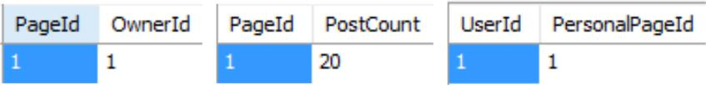

**2. Sign in and sign out**

SELECT * FROM UserPlus WHERE userId=? AND password=?;

**Statements:**

SELECT * FROM UserPlus WHERE userId=1 AND password="apples";

|  |  |  |  |  |  |
| --- | --- | --- | --- | --- | --- |
| **Output:** |  |  |  |  |  |
| UserId Password | FirstName | LastName | Address | City State ZipCode | Phone Email |
| AccountNum | AccountCreationDate CreditCardNum | | | Preferences |  |

|  |  |  |  |  |  |  |
| --- | --- | --- | --- | --- | --- | --- |
| 1 | apples Michael | Thorne "4363 Arrowood Drive" | | Jacksonville FL | | 32216 9044166609 |
|  | MichaelCThorne@gmail.com 1 | | "2016-11-07 17:02:58" | | 5443350608517143 applePicking | |

**3. Post messages into personal page**

INSERT INTO POST(PostID, DateCreated, Content, CommentCount, AuthorID) values (?, ?, ?, ?, ?);

INSERT INTO PostedTo(PostID, PageID) values (?, ?);

**Statements:**

INSERT INTO Post (PostId, DateCreated, Content, CommentCount, AuthorId) VALUES (1, NOW(), 'envisioneer frictionless deliverables', 10, 1);

INSERT INTO PostedTo(PostID, PageID) VALUES (1, 1);

**Output:**

SELECT * FROM Post WHERE AuthorId = 1;

SELECT * FROM PostedTo WHERE PostID = 1;



**4. Send a message**

SELECT UserId From UserPlus WHERE UserId=?;

INSERT INTO Message(MessageID, DateSent, ReceiverID, SenderID, Subject, Content) values (?, ?, ?, ?, ?, ?);

INSERT INTO Send(Sender, MessageID) values (?, ?);

**Statements:**

INSERT INTO Message(MessageID, DateSent, ReceiverID, SenderID, Subject, Content) values (1, NOW(),

2, 1, “subject”, “apples”);

INSERT INTO Send(Sender, MessageID) values (1, 1);

SELECT * FROM Message WHERE SenderId = 1;

SELECT * FROM Send WHERE Sender = 1;

**Output:**

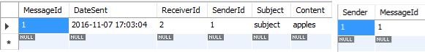

**5. Receive a message**

SELECT UserId From UserPlus WHERE UserId=?;

INSERT INTO Receive(Receiver, MessageId) values (?, ?);

**Statements:**

SELECT UserId FROM UserPlus WHERE UserId=2;

INSERT INTO Receive(Receiver, MessageId) VALUES (2, 1);

**Output:**

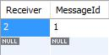

**6. Delete a message**

DELETE FROM Message WHERE MessageID = ?;

**Statements:**

DELETE FROM Message WHERE MessageID = 1;

**Output:**



**7. Create Group**

INSERT INTO GroupPlus(GroupID, GroupName, Owner, Type) values (?, ?, ?, ?); INSERT INTO PagePlus(PageID, PostCount) values(?, ?);

INSERT INTO GroupPage(PageId, GroupID) values(?, ?);

INSERT INTO HasAGroupPage(GroupID, GroupPageID) values(?, ?); INSERT INTO HasAccessToGroup(UserId, PageID, GroupID) values (?, ?, ?);

**Statements:**

INSERT INTO GroupPlus (GroupId, Owner, GroupName) VALUES (26, 1, 'Automated value-added process improvement');

INSERT INTO PagePlus (PageId, PostCount) VALUES (26, 0);

INSERT INTO GroupPage(PageId, GroupID) VALUES(26, 26);

INSERT INTO HasAGroupPage(GroupID, GroupPageID) VALUES(26, 26);

INSERT INTO HasAccessToGroup(UserId, AdderId, PageID, GroupID) VALUES(1, NULL, 26, 26);

**Output:**



**8. Search for a user and add him to a group**

SELECT * FROM HasAccessToGroup WHERE AdderID = ? AND GroupID = ?;

INSERT INTO HasAccessToGroup(UserID, PageID, GroupID) values (?/*Target_Id*/, ?, ?);

**Statements:**

SELECT * FROM HasAccessToGroup WHERE AdderID = NULL AND GroupID = 26 AND UserID = 1; INSERT INTO HasAccessToGroup(UserID, AdderID, PageID, GroupID) VALUES (11, 1, 26, 26);

**Output:**



**9. Make a post**

SELECT * FROM HasAPersonal WHERE UserID = ? AND PersonalPageID = ?; -- check if it is a personal page SELECT * FROM HasAccessToGroup WHERE AdderID = ? AND GroupId = ?; -- check if has access to group INSERT INTO PostedTo(PostID, PageID) values (?, ?); -- insertion

**Statements:**

SELECT * FROM HasAPersonal WHERE UserID = 1 AND PersonalPageID = 1;

INSERT INTO Post (PostId, DateCreated, Content, CommentCount, AuthorId) VALUES (1, NOW(), 'envisioneer frictionless deliverables', 10, 1);

INSERT INTO PostedTo(PostID, PageID) VALUES(1, 1);

**Output:**



**10. Comment on a post**

INSERT INTO Comment(CommentID, DateCreated, Content, AuthorID) VALUES (?, ?, ?, ?); INSERT INTO CommentOn(CommentID, PostID) VALUES (?, ?);

**Statements:**

INSERT INTO Comment(CommentID, DateCreated, Content, AuthorID) VALUES (1, NOW(), '2', 1); INSERT INTO CommentOn(CommentID, PostID) VALUES(1, 1);

**Output:**



**11. Like a post**

INSERT INTO LikesPost(PostID, UserID) VALUES(?, ?);

**Statements:**

INSERT INTO LikesPost(PostID, UserID) VALUES (1, 1);

**Output:**

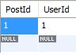

**12. Like a comment**

INSERT INTO LikesComment(CommentID, UserID) VALUES(?, ?);

**Statements:**

INSERT INTO LikesComment(CommentID, UserID) VALUES(1, 1);

**Output:**

SELECT * FROM LikesComment WHERE CommentID=1 AND UserID=1;

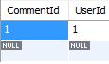

**13. Remove a user from a group**

DELETE FROM HasAccessToGroup WHERE UserID = ? AND GroupID = ?;

**Statements:**

DELETE FROM HasAccessToGroup WHERE UserID = ? AND GroupID = ?;

**Output:**



**14. Remove a post**

DELETE FROM PostedTo WHERE PostID = ? AND PageID = ?;

**Statements:**

DELETE FROM PostedTo WHERE PostID = ? AND PageID = ?; -- CASCADE will DELETE the post

**Output:**



**15. Remove a comment**

DELETE FROM CommentOn WHERE CommentID = ? AND PostID = ?;

**Statements:**

DELETE FROM CommentOn WHERE CommentID = 1 AND PostID = 1;

**Output:**



**16. Unlike a post**

DELETE FROM LikesPost WHERE PostID = ? AND UserID = ?;

**Statements:**

DELETE FROM LikesPost WHERE PostID = 1 AND UserID = 1;

**Output:**



**17. Unlike a comment**

DELETE FROM LikesComment WHERE CommentId = ? AND UserId = ?;

**Statements:**

DELETE FROM LikesComment WHERE CommentID = ? AND UserID = ?;

**Output:**



**18. Modify a post**

UPDATE Post SET DateCreated = ?, Content = ?, CommentCount = ? WHERE PostId = ?;

**Statements:**

UPDATE Post SET DateCreated = NOW(), Content = "hey whats up?", CommentCount = 1 WHERE PostId = 2;

**Output:**



**19. Modify a comment**

UPDATE Comment SET DateCreated = NOW(), Content = "this is great" WHERE CommentId = 5;

**Statements:**

UPDATE Comment SET DateCreated = NOW(), Content = "this is great" WHERE CommentId = 5;

**Output:**

*Before:*

**

*After:*

**

**20. Delete a group**

DELETE FROM GroupPlus WHERE GroupId = ?;

**Statements:**

DELETE FROM GroupPlus WHERE GroupId = 31;

**Output:**



**21. Add employee**

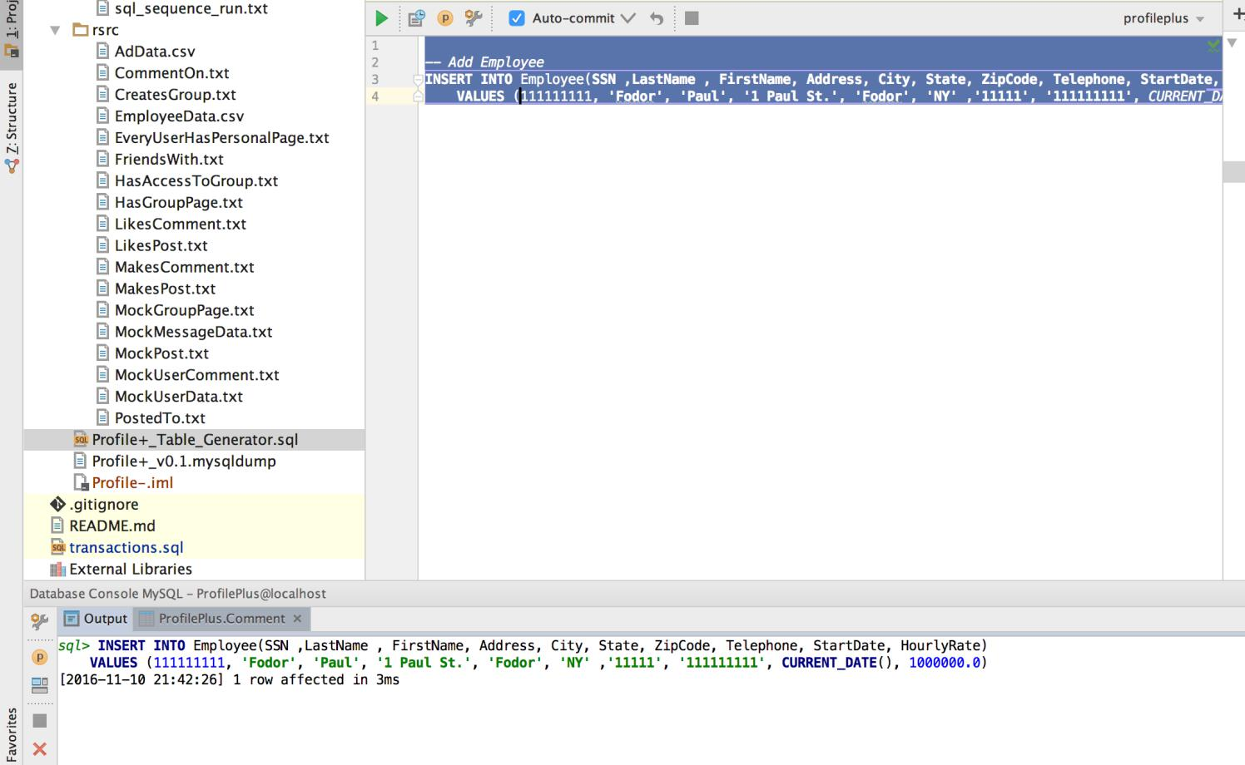

**22. Comment on a post on a group page**

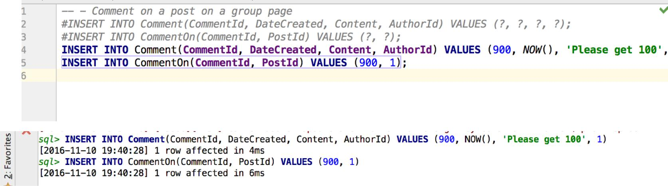

**23. Delete employee**

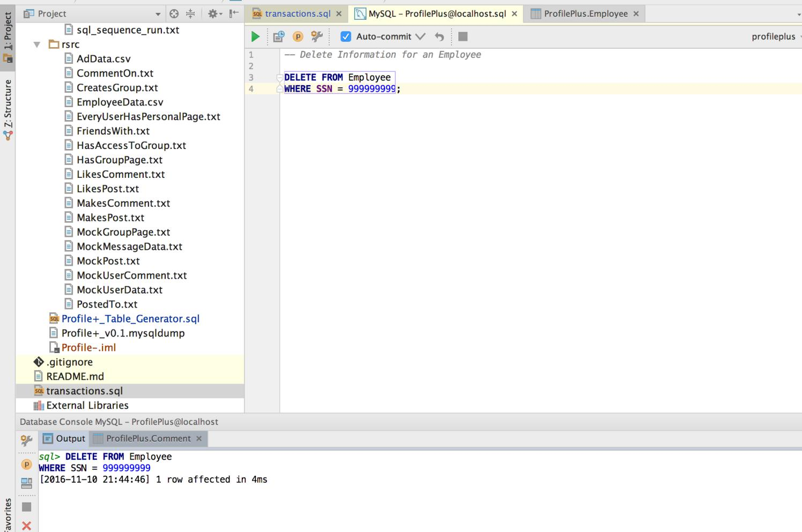

**24. Join group**

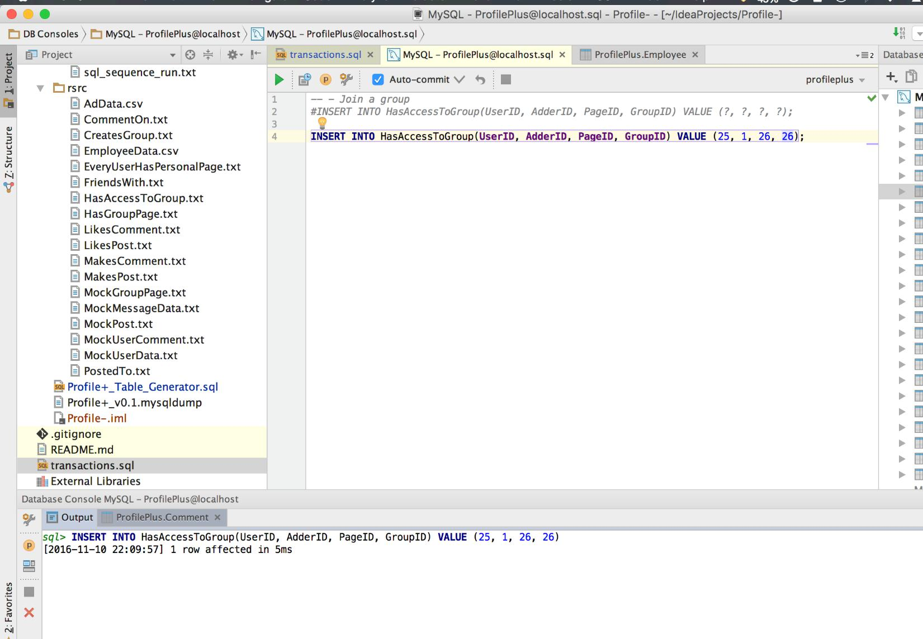

**25. Like a post from a group page**

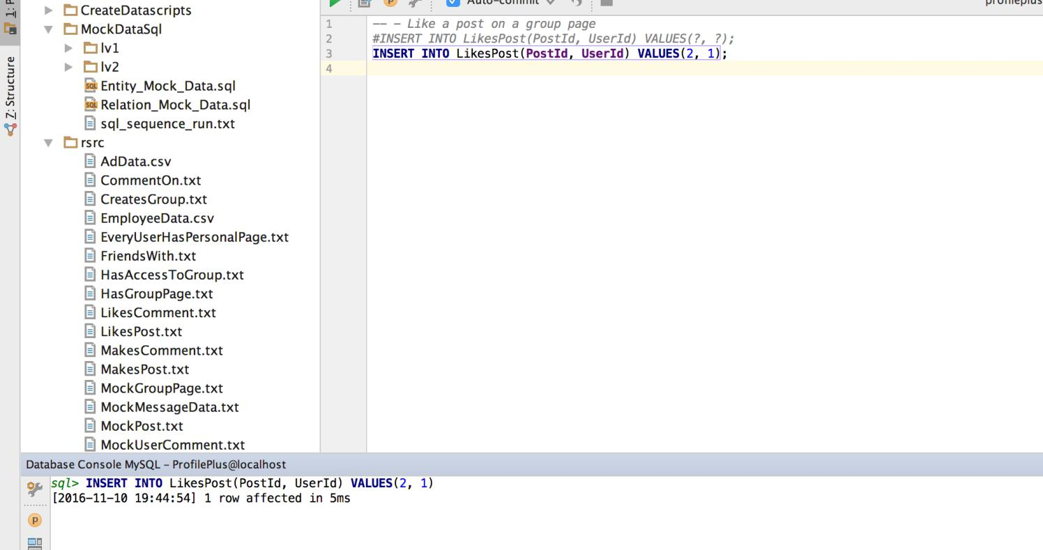

**26. Like a comment from a group**

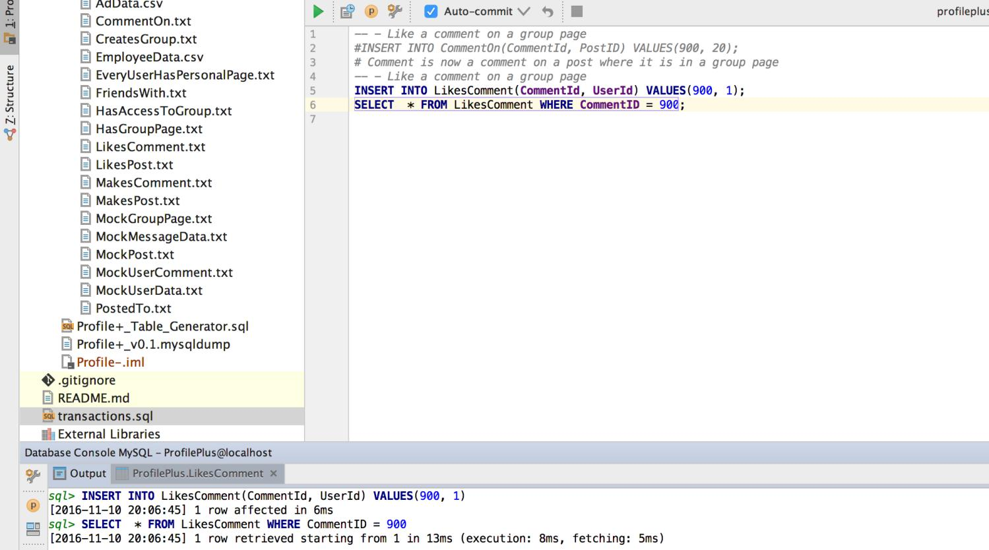

**27. Remove comment in a group**

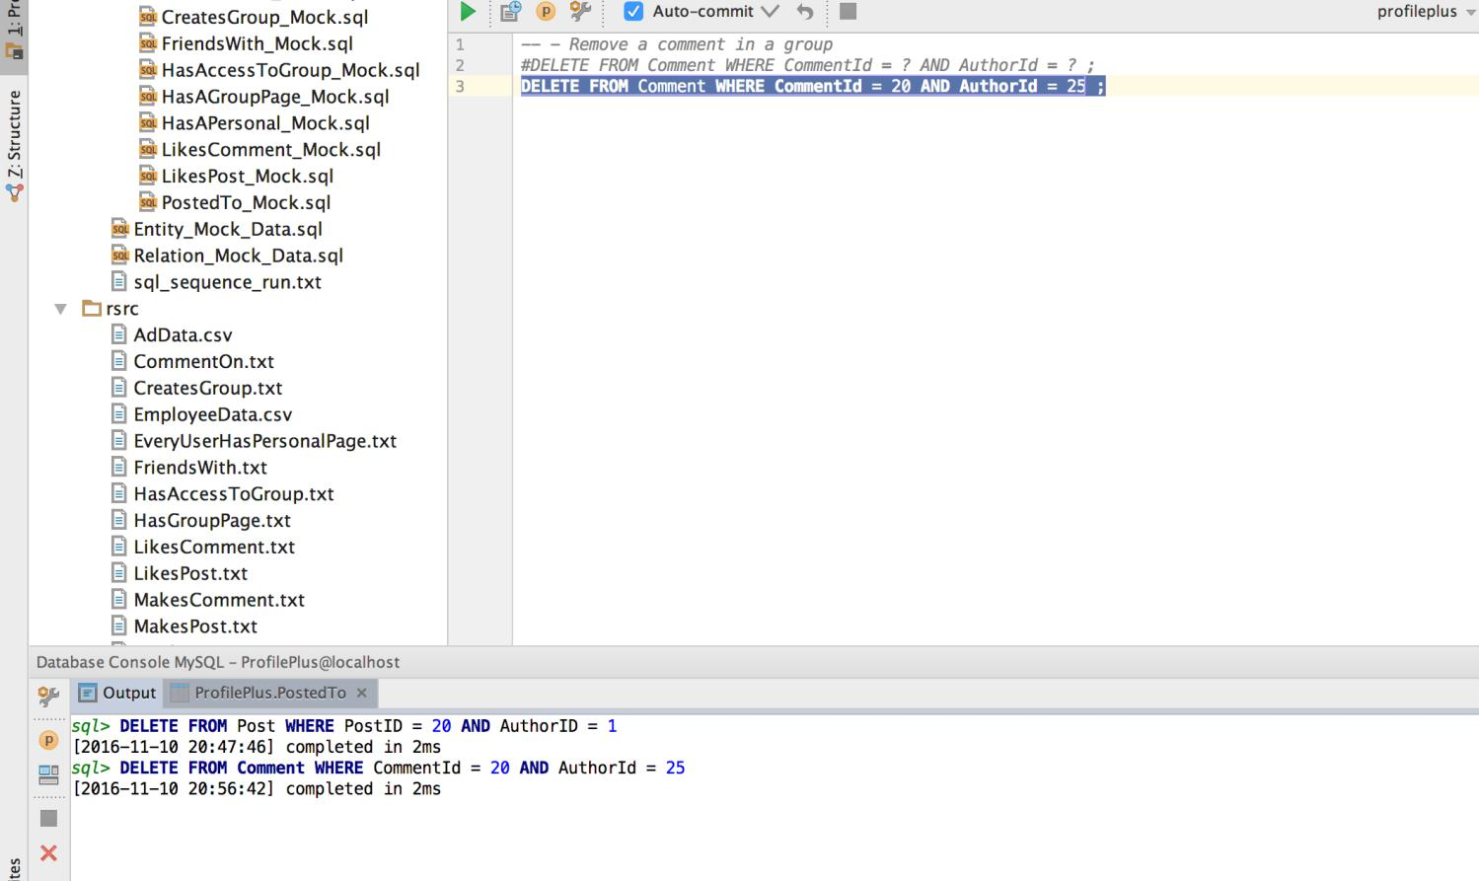

**28. Remove a post from a group page**

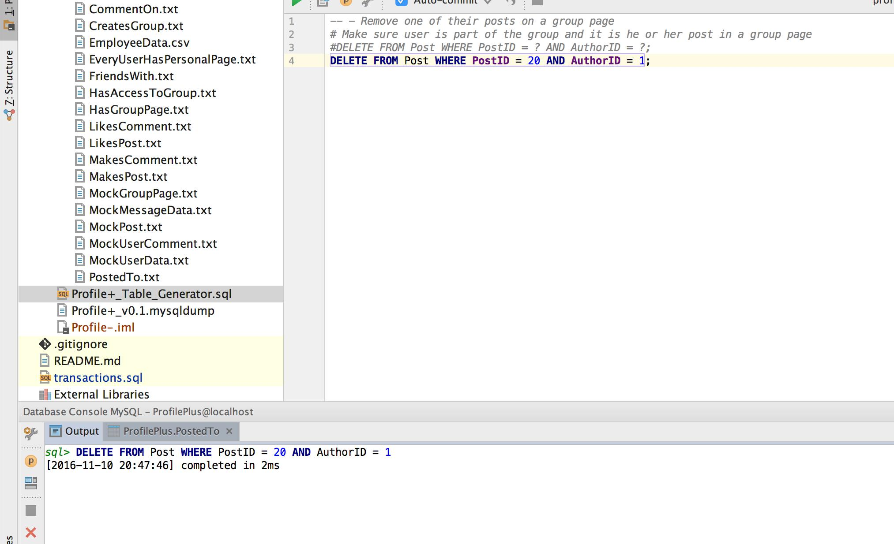

**29. Rename a group**

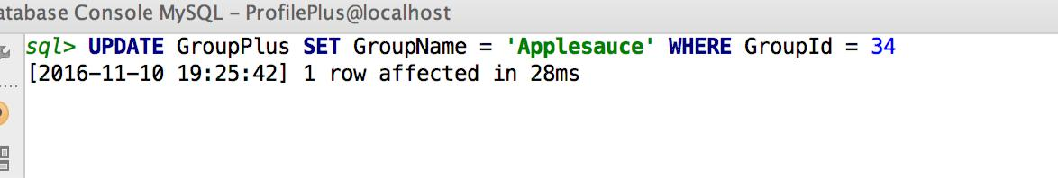

**30. Select has access**

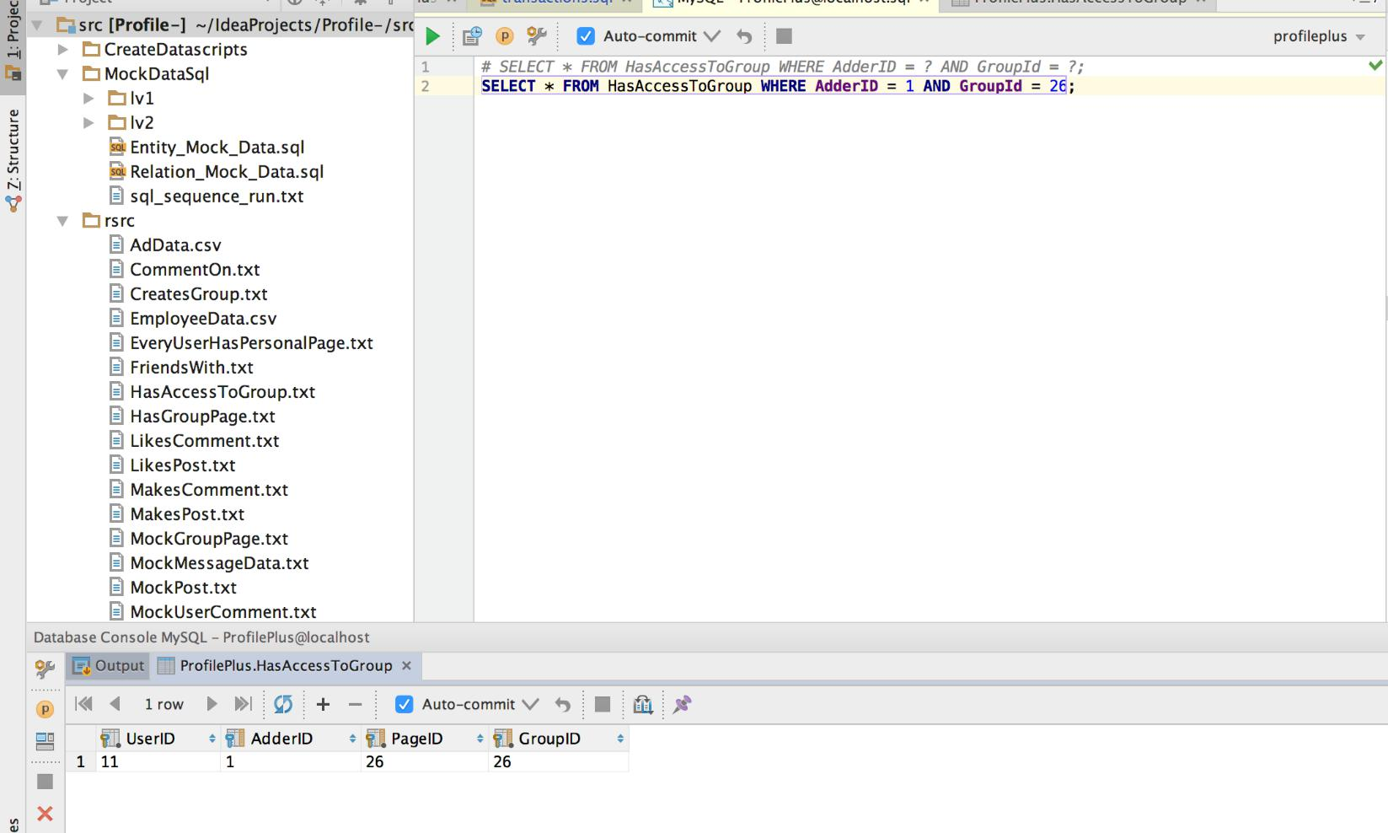

**31. Select has access to group**

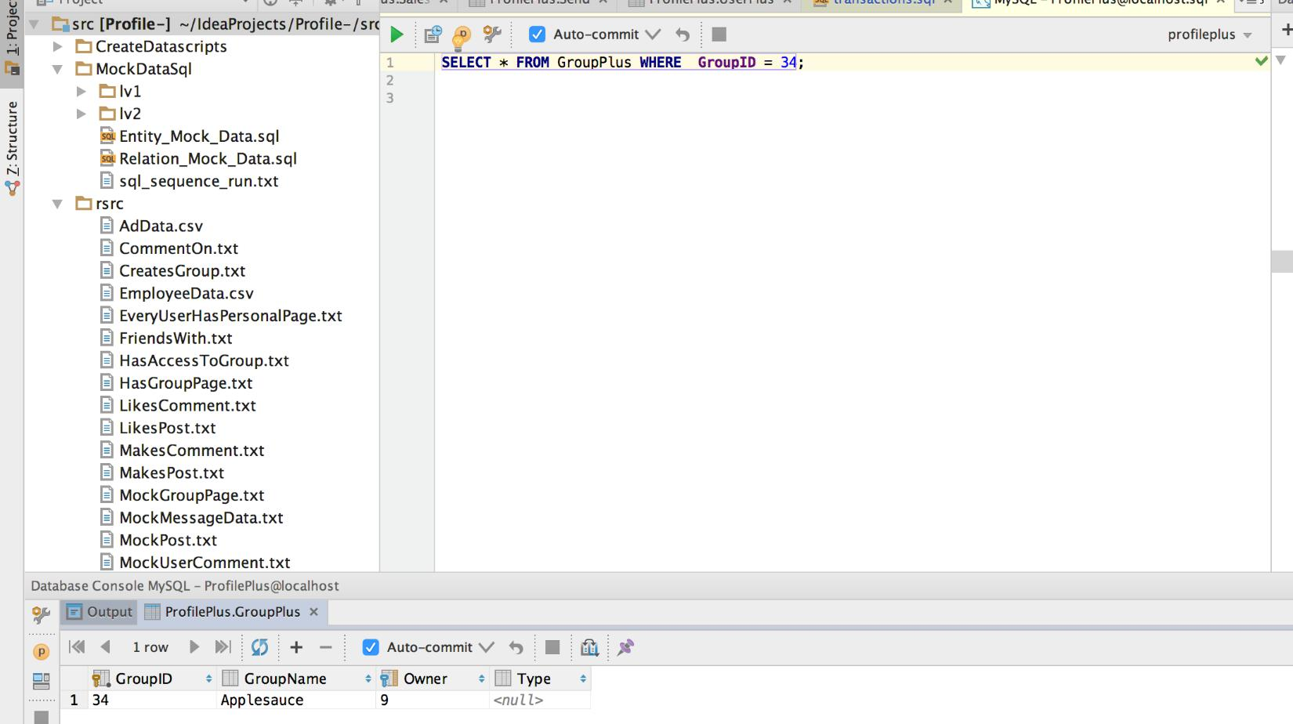

**32. Select has personal page**

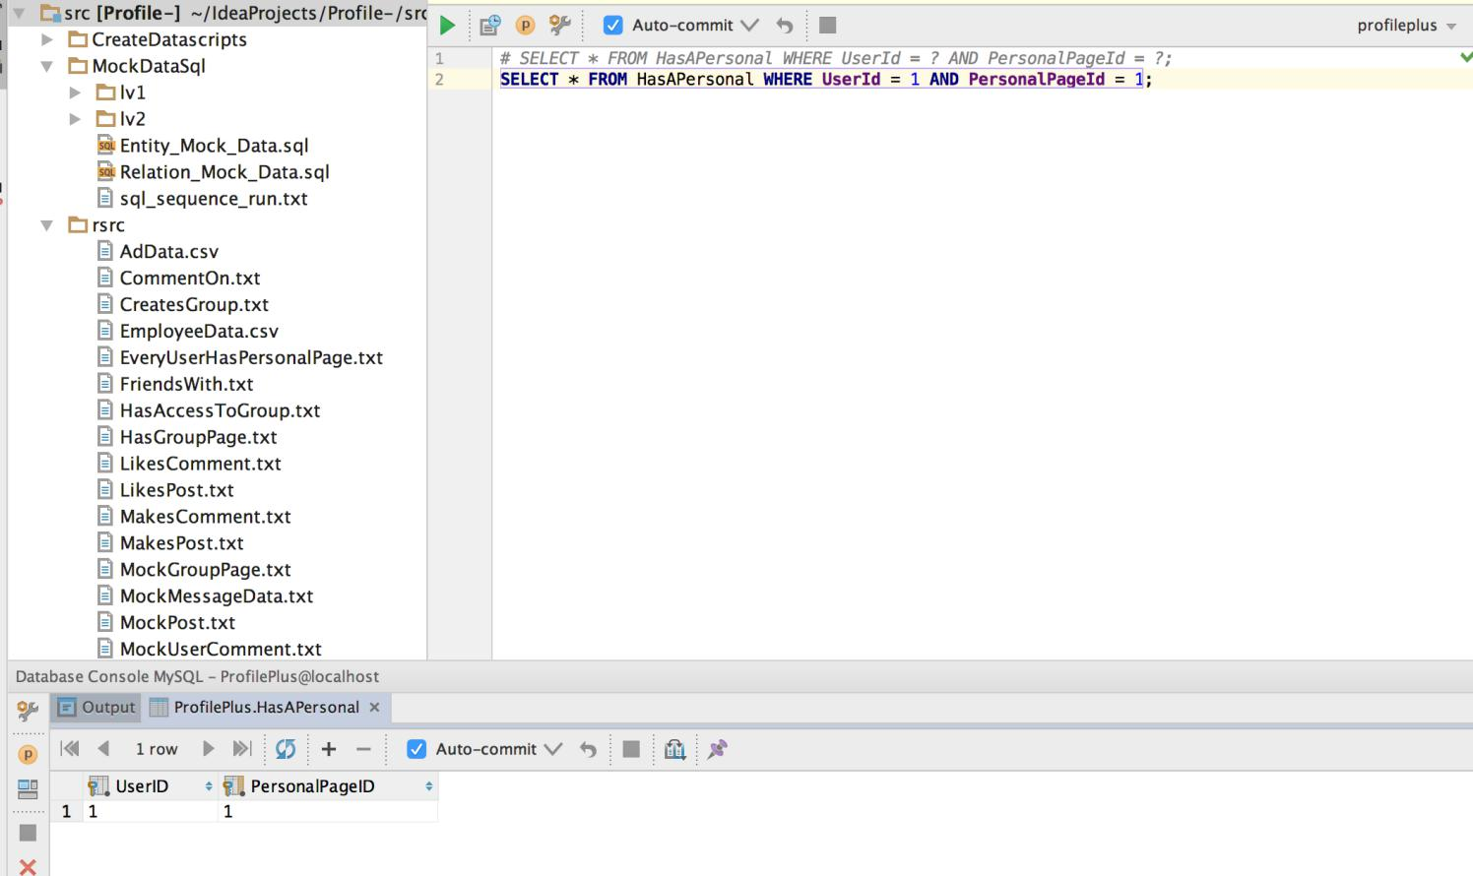

**33. Unjoin a group**

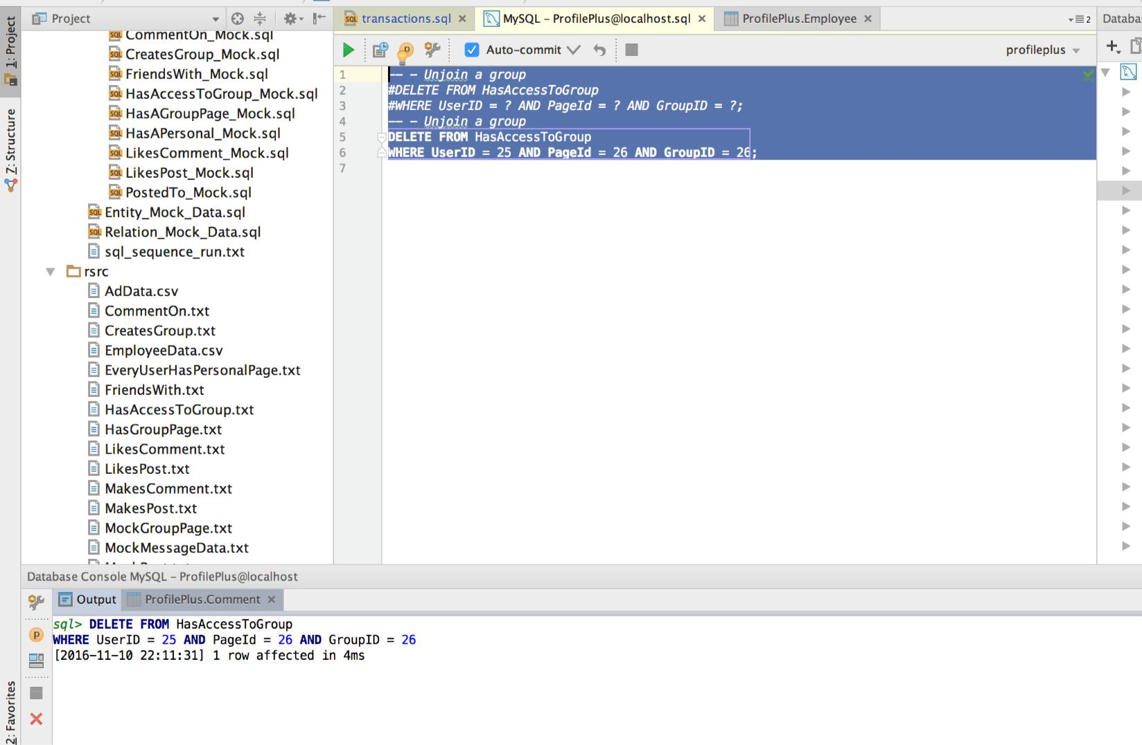

**34. Unlike a comment in a group page**

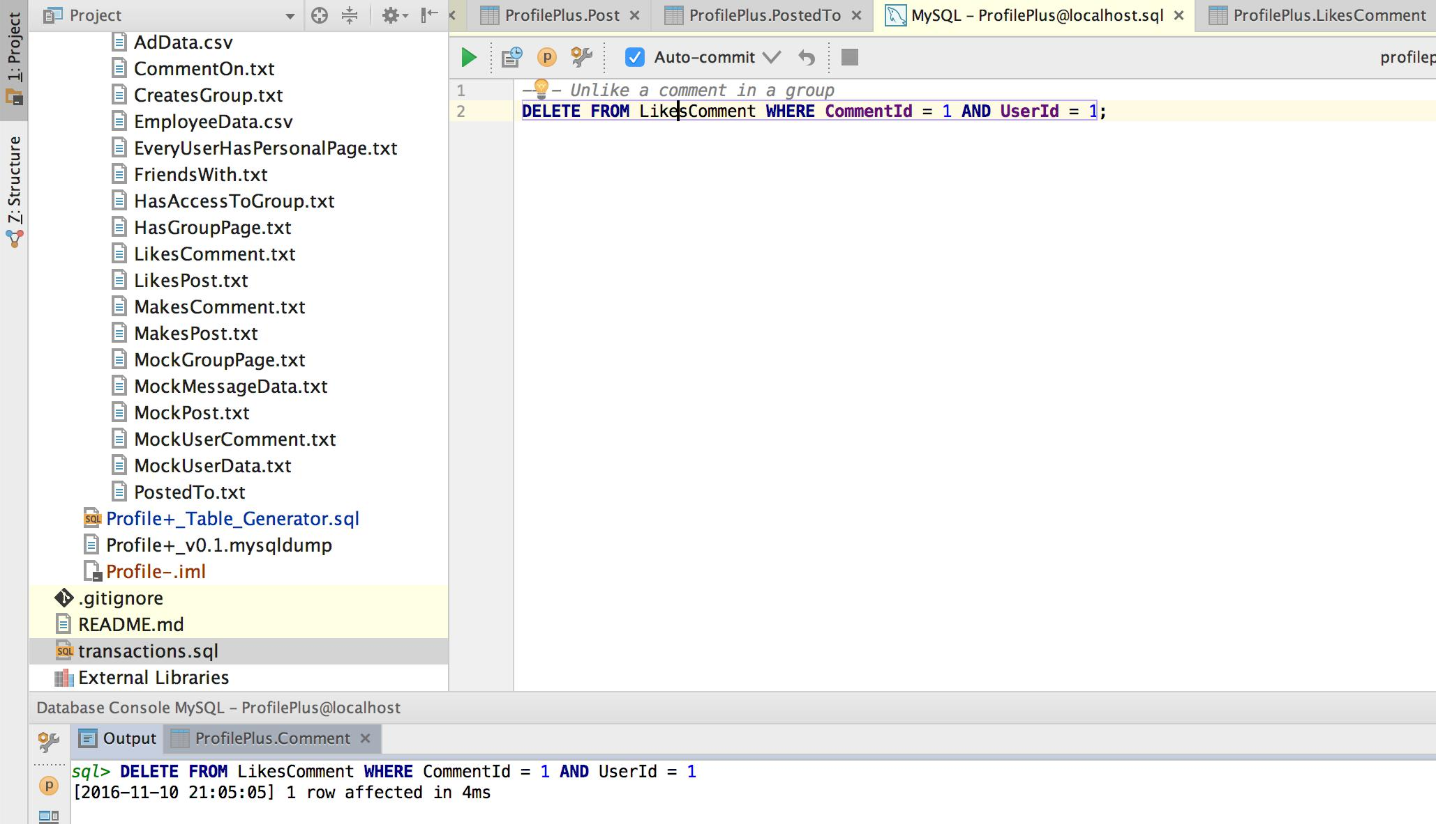

**35. Unlike a post from a group page**

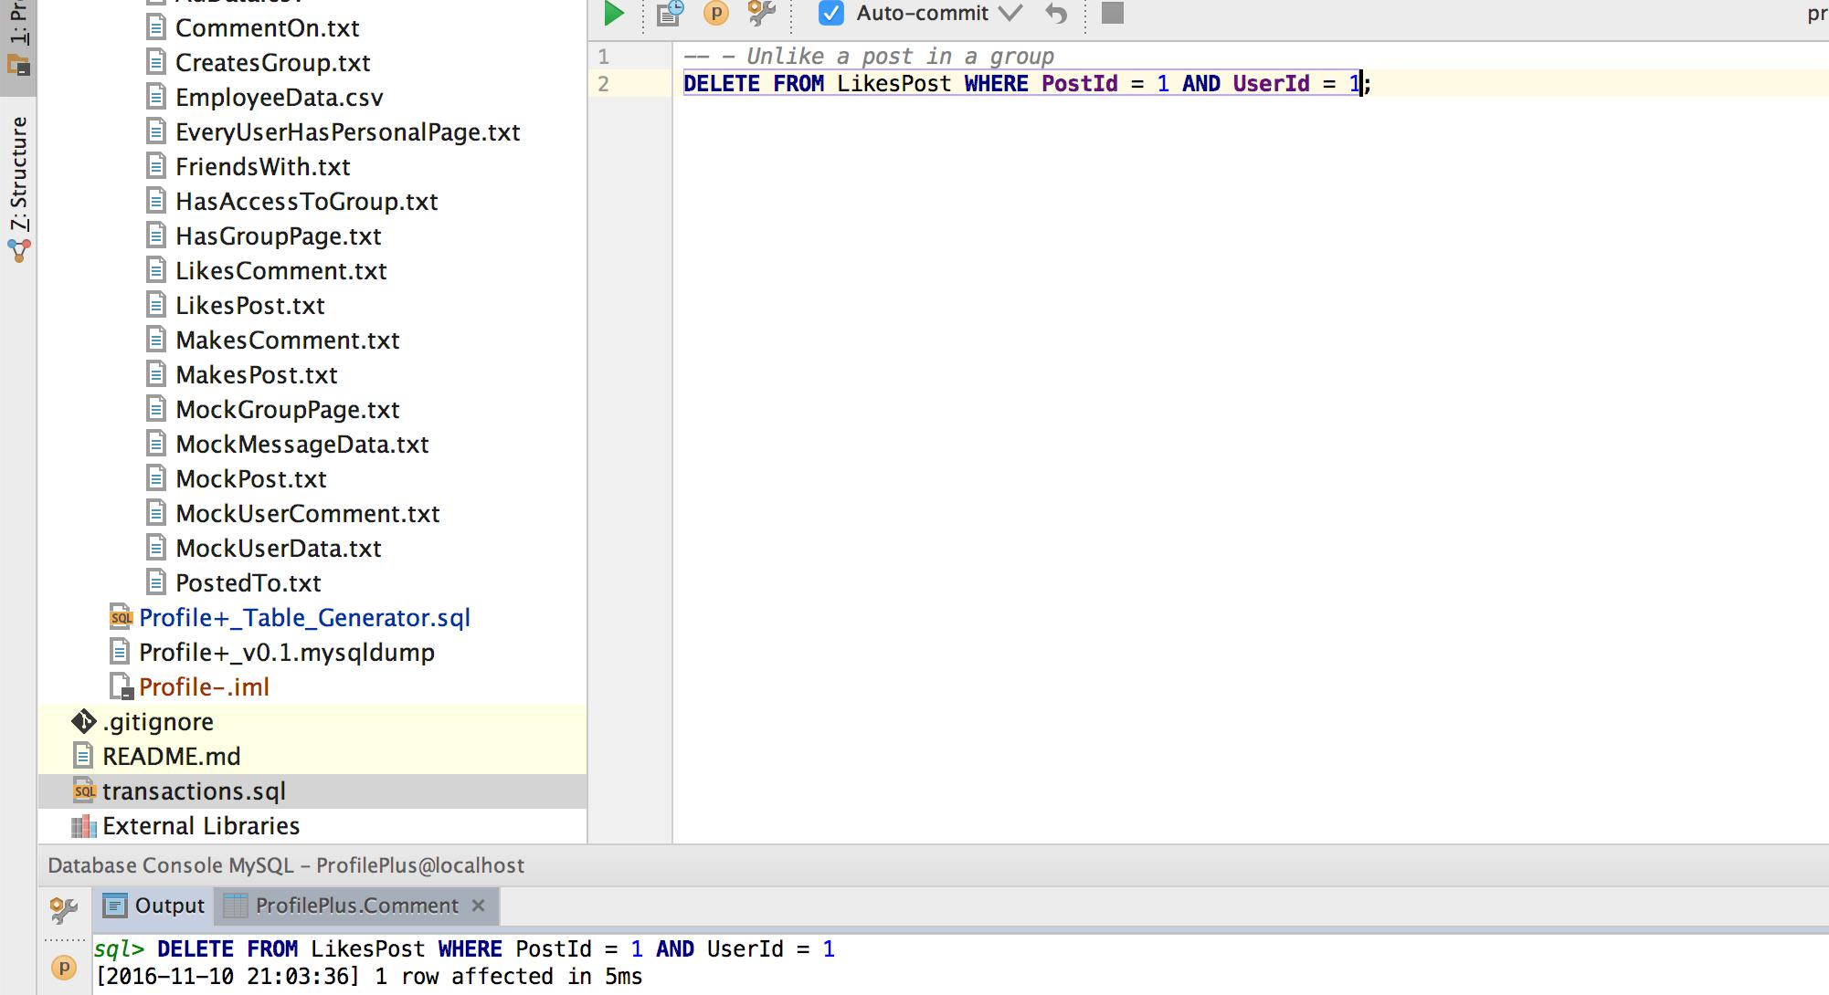

**36. Modify a comment in a group**

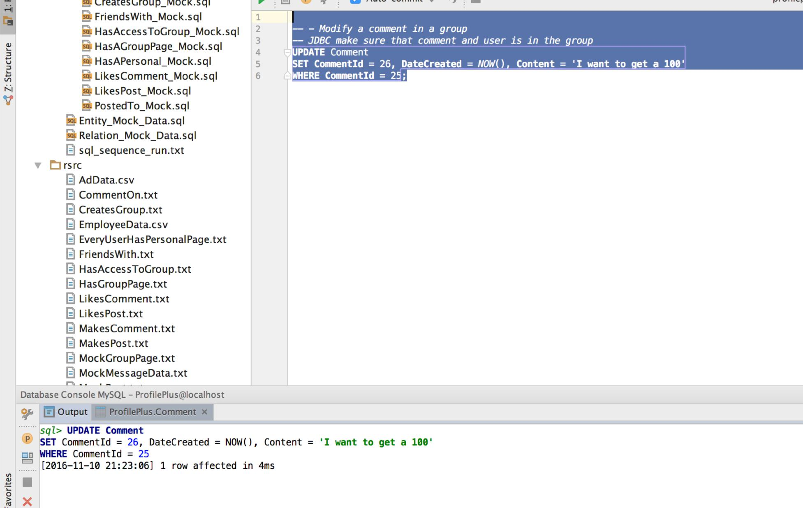

**37. Edit employee**

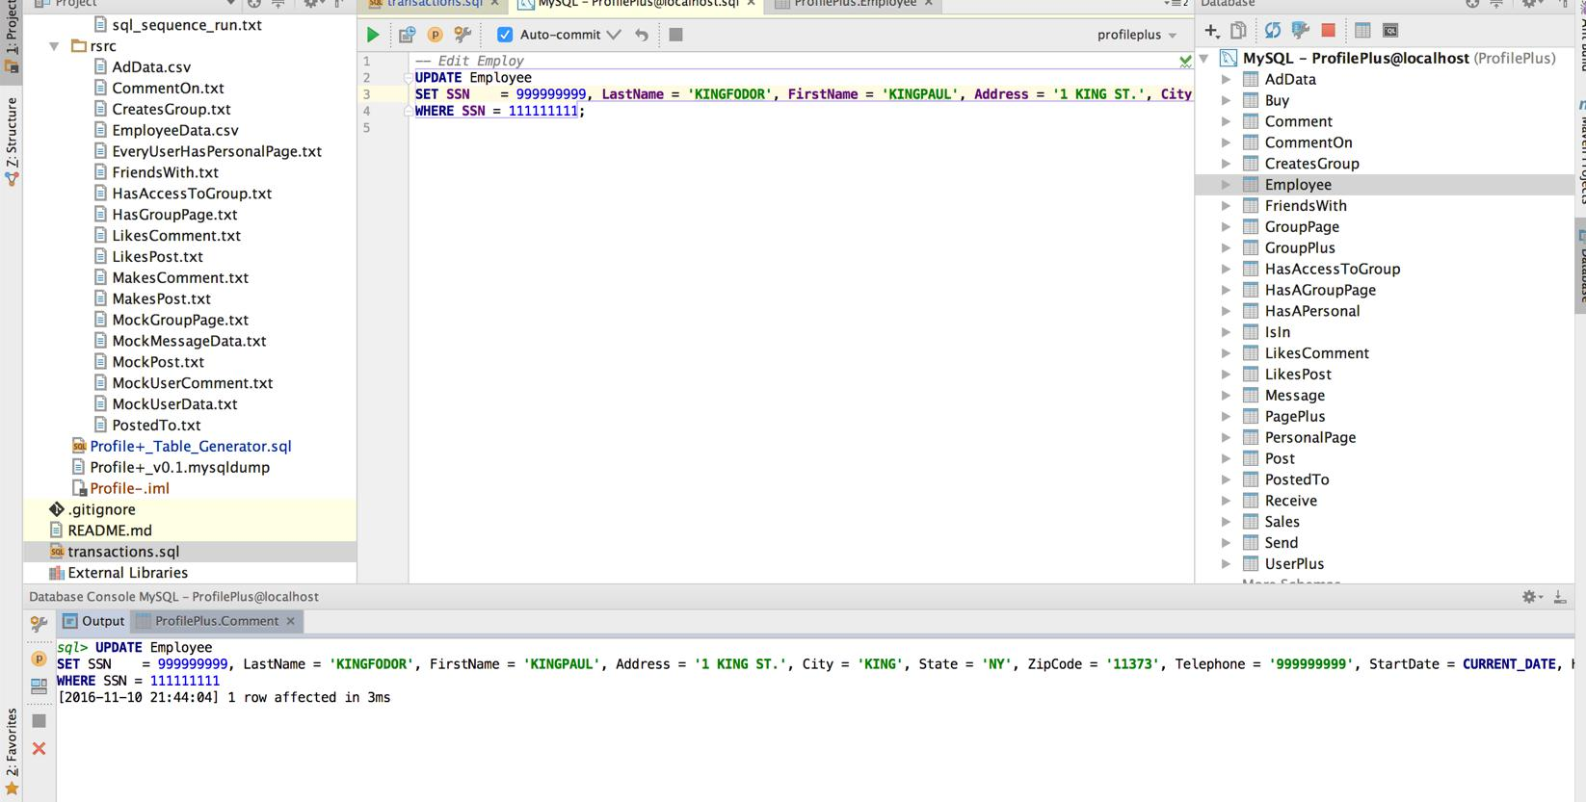

**38. Modify a post in a group**

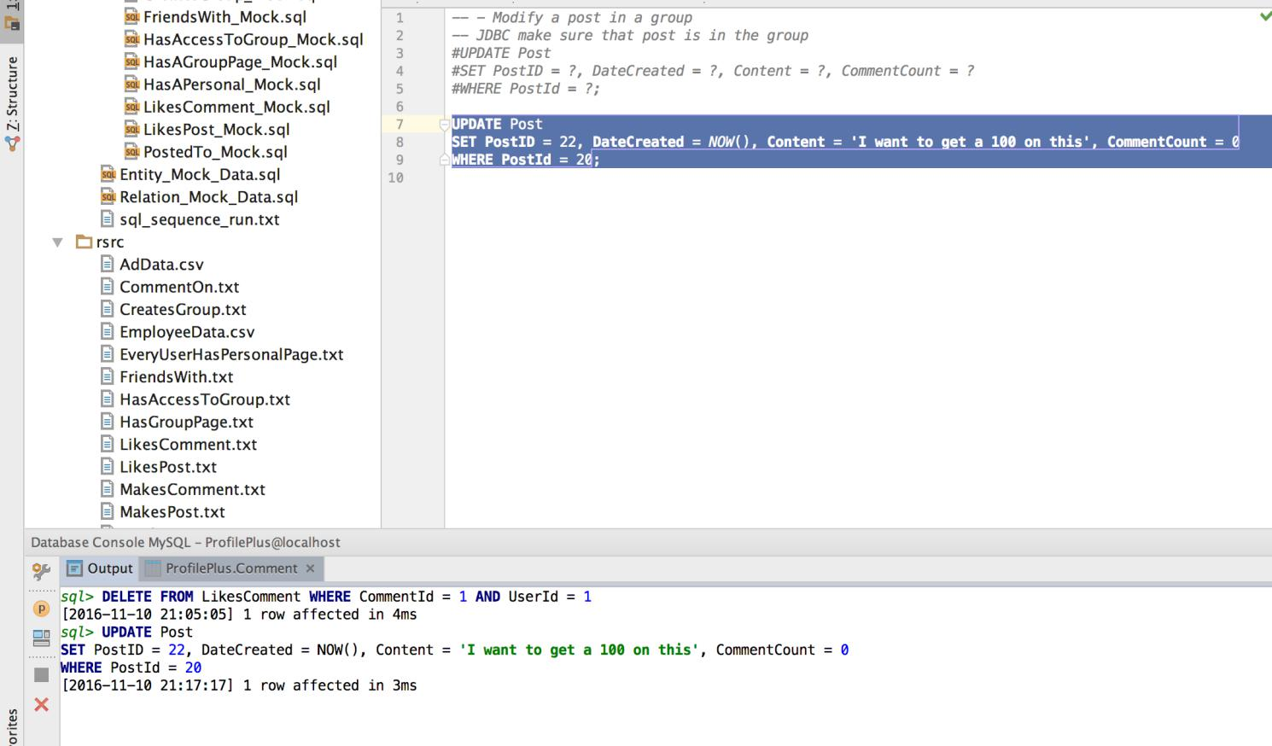

**39. Obtain a sales report for a particular month**

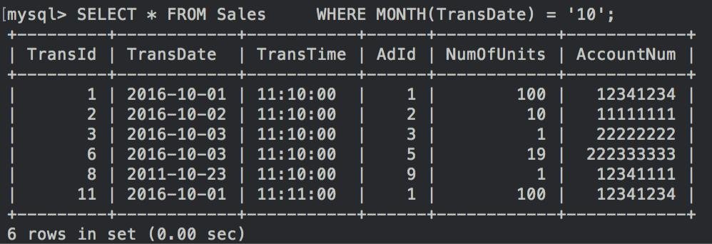

**40. Produce a comprehensive listing of all items being advertised on the site** -

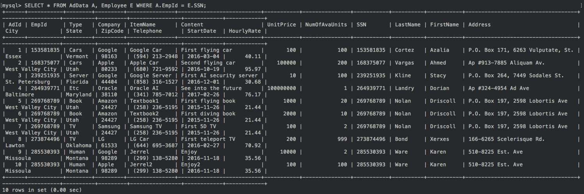

**41. Produce a list of transactions by item name or by user name**

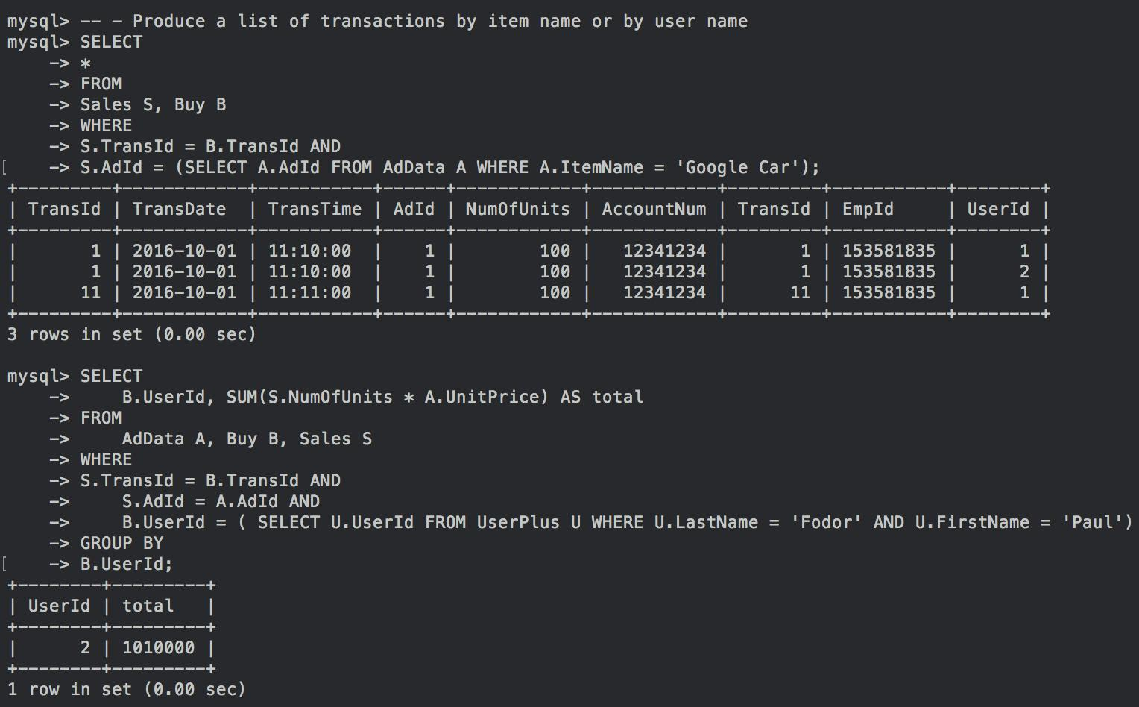

**42. Produce a summary listing of revenue generated by a particular item, item type, or customer**

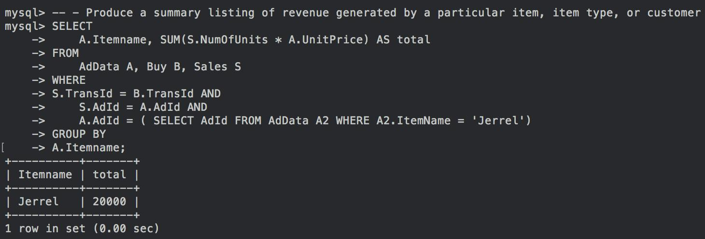

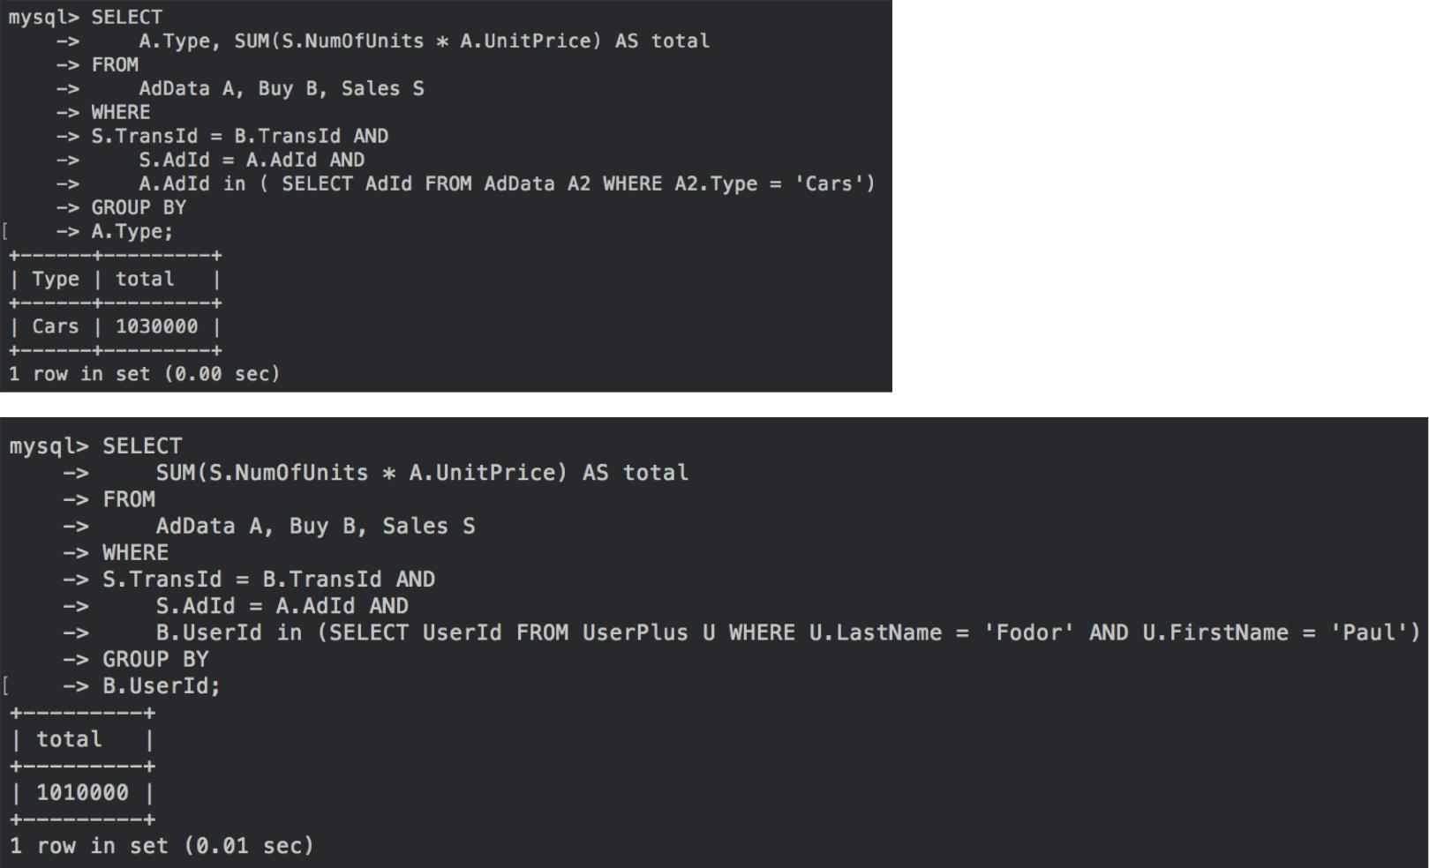

**43. Determine which customer representative generated most total revenue**

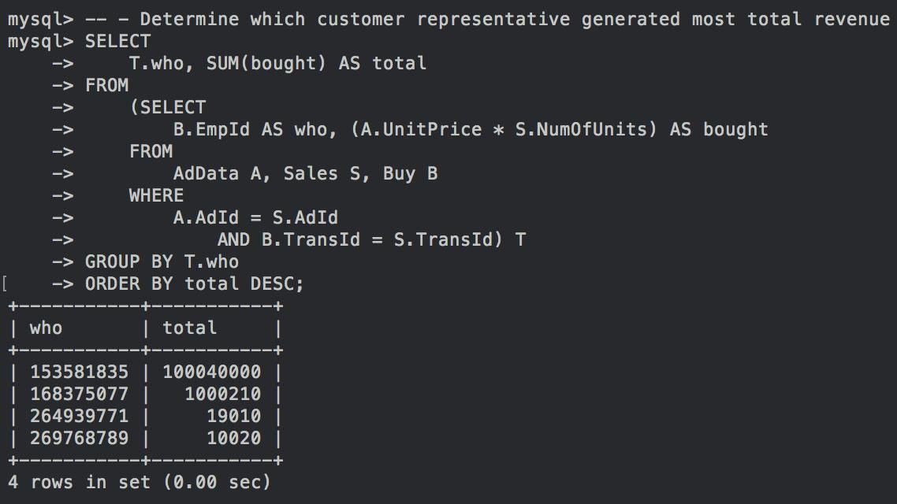

**44. Determine which customer generated most total revenue**

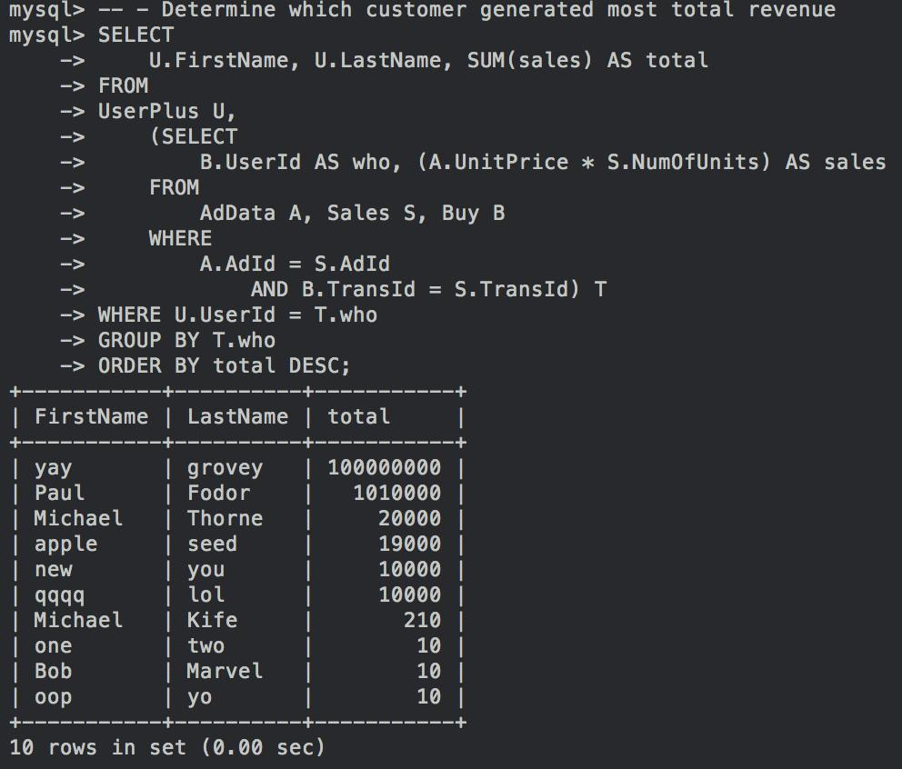

**45. Produce a list of most active items**

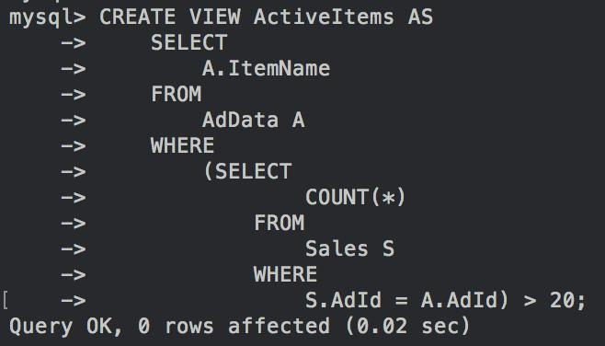

**46. Produce a list of all customers who have purchased a particular item**

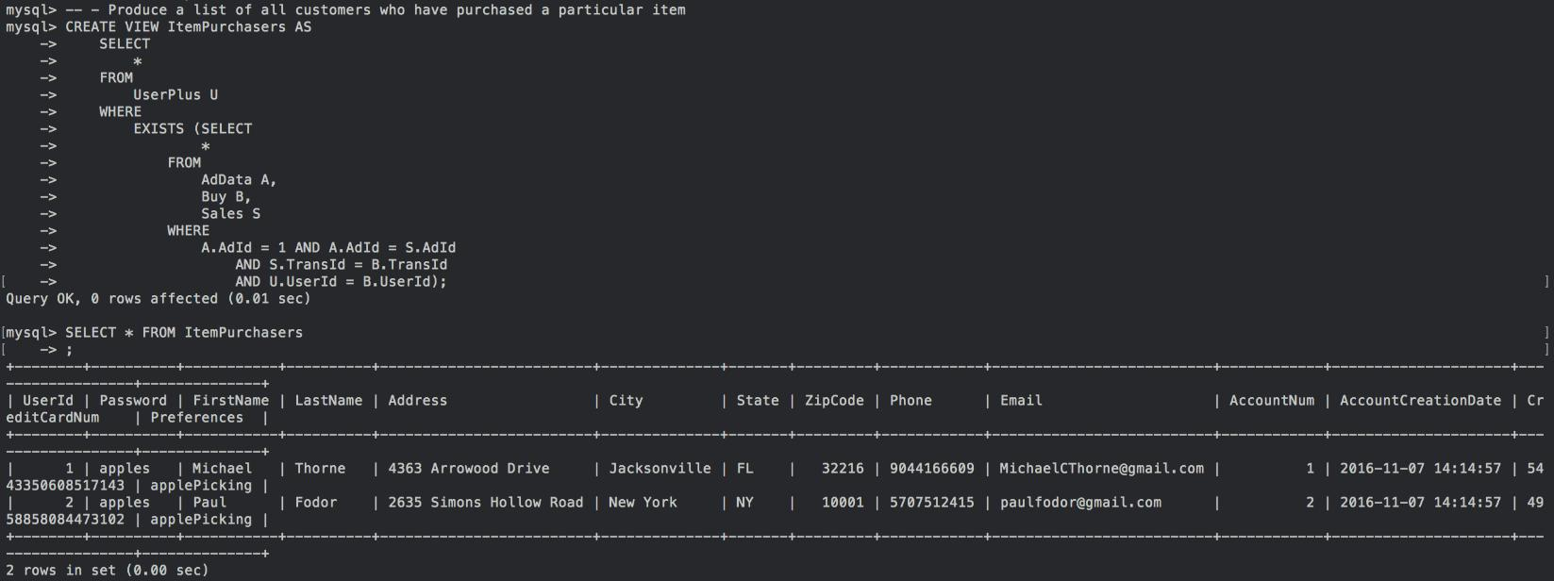

**47. Produce a list of all items for a given company**

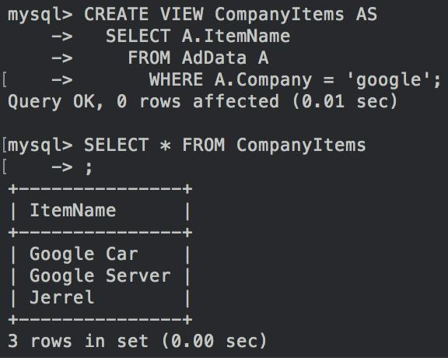

**48. Create and delete an advertisement**

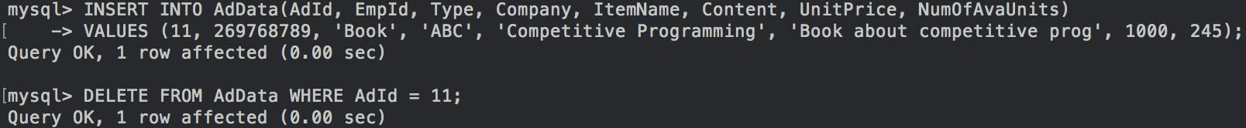

**49. Record a transaction**

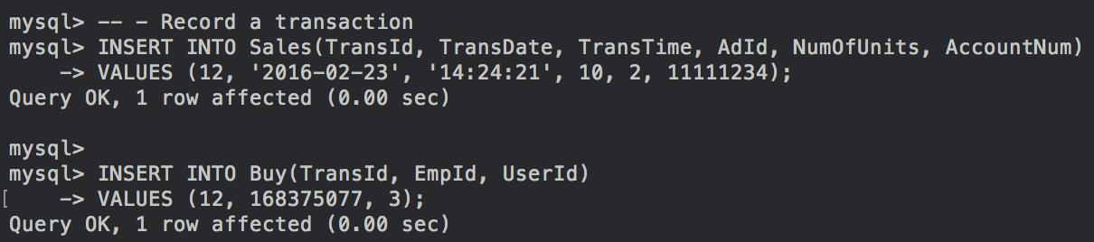

**50. Produce customer mailing lists**

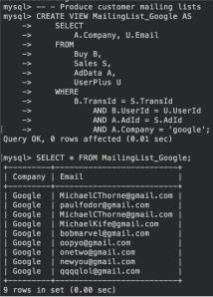

**51. Produce a list of item suggestions for a given customer (based on that customer's past transactions)**

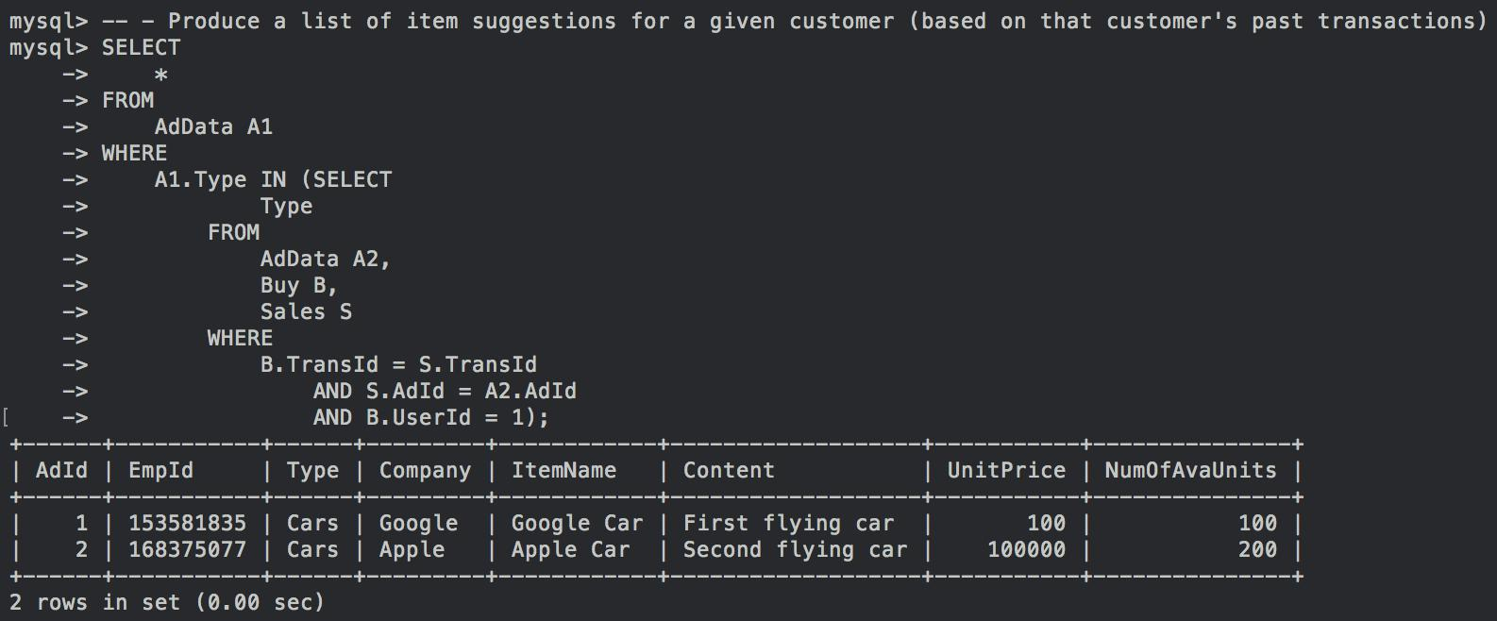

1. **Purchase one or more copies of an advertised item**
2. **Retrieve a customer’s current groups**

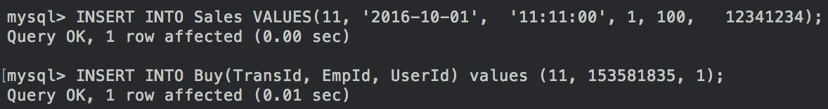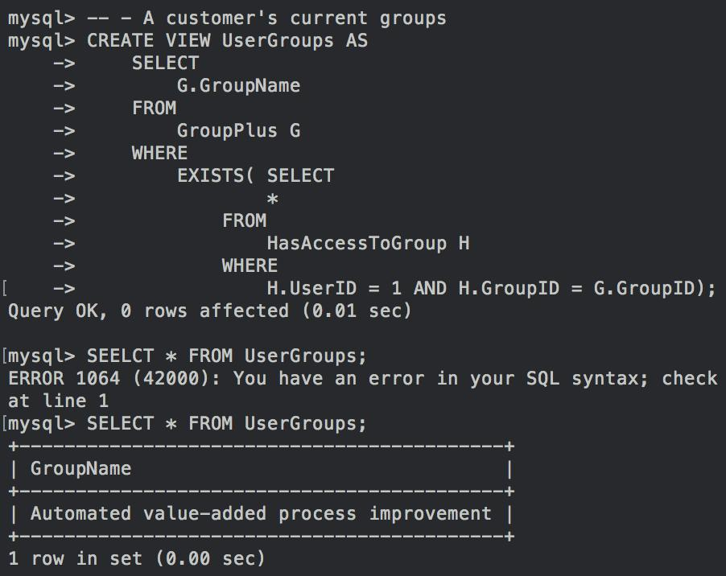

**54. Retrieve for each of a customer's accounts, the account history**

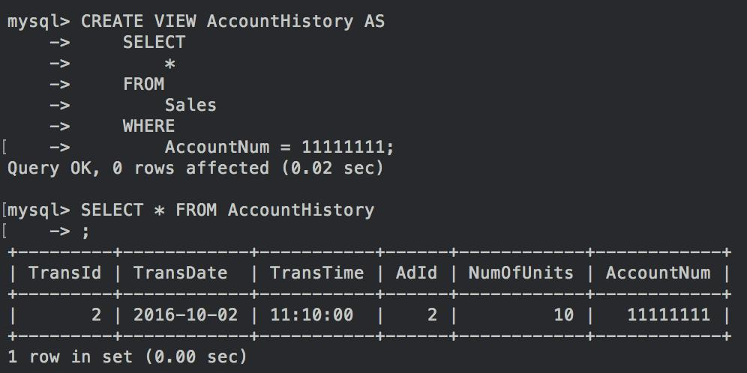

**55. Retrieve best-seller list of items**

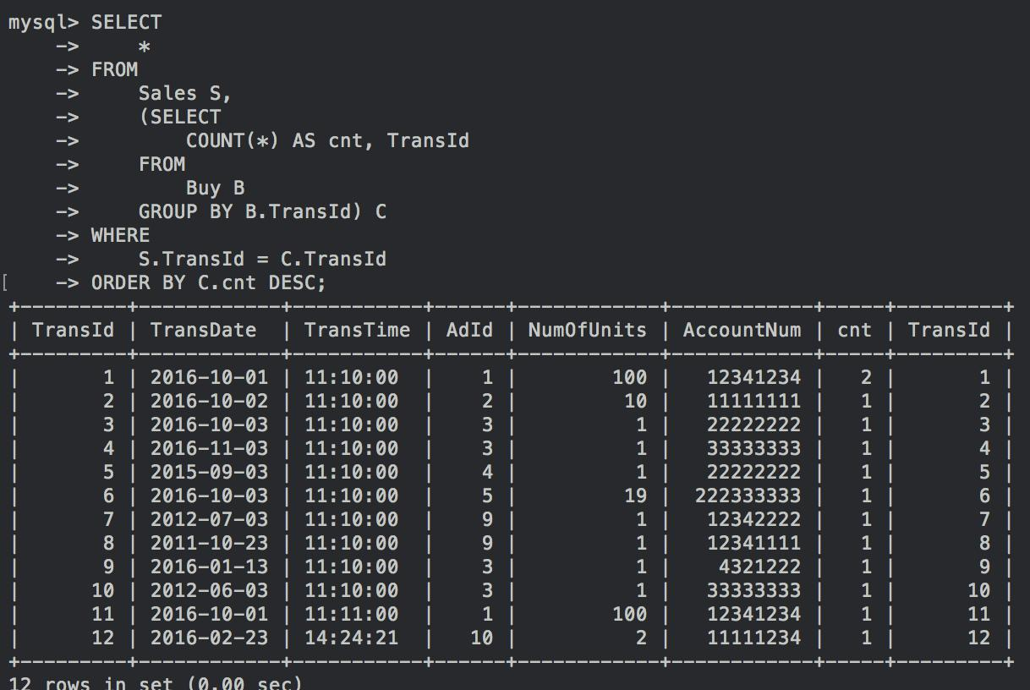

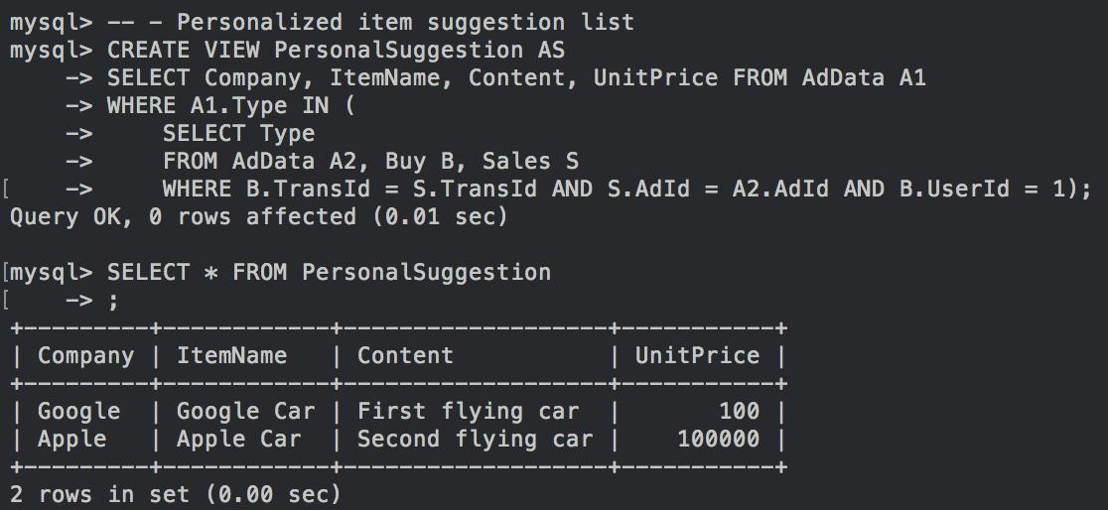**56. Retrieve a personalized item suggestion list**

**III. Phase 3**

**Customer-Level Transactions:**

* + Register

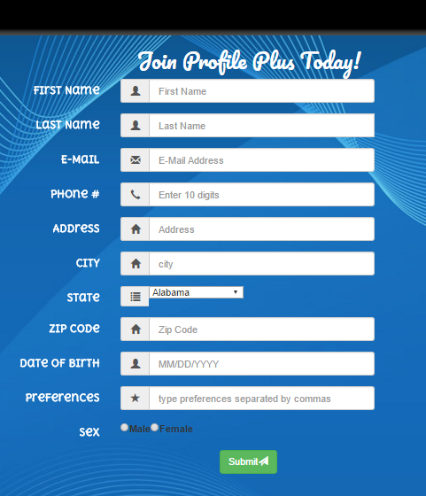

* + Sign in and sign out

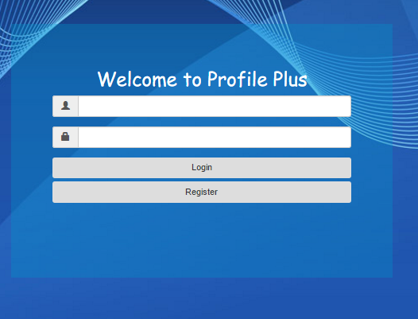

* + Post messages on personal pages

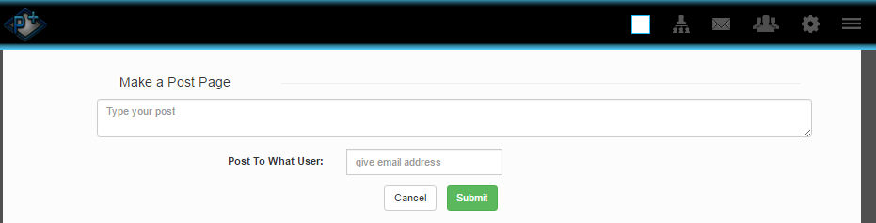

* + Send a message, Receive a message, Delete a message

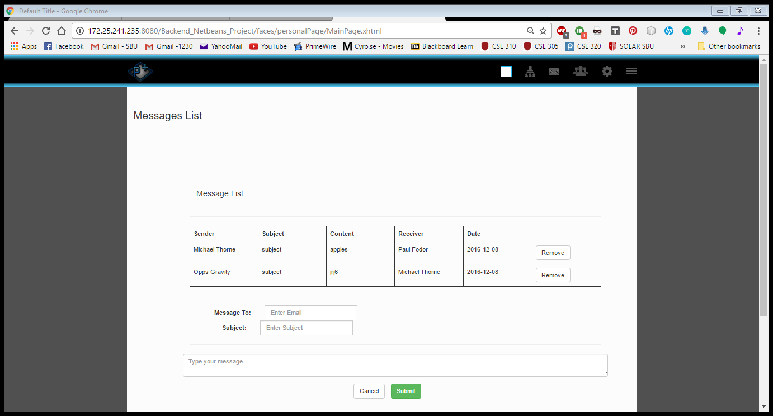

**Groups:**

* + Create a group

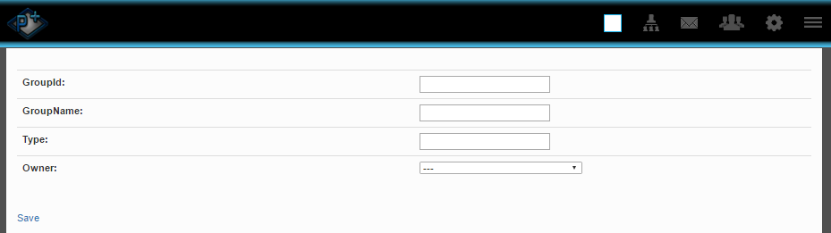

* + Search for a user and add him to a group, Join a group, Unjoin a group

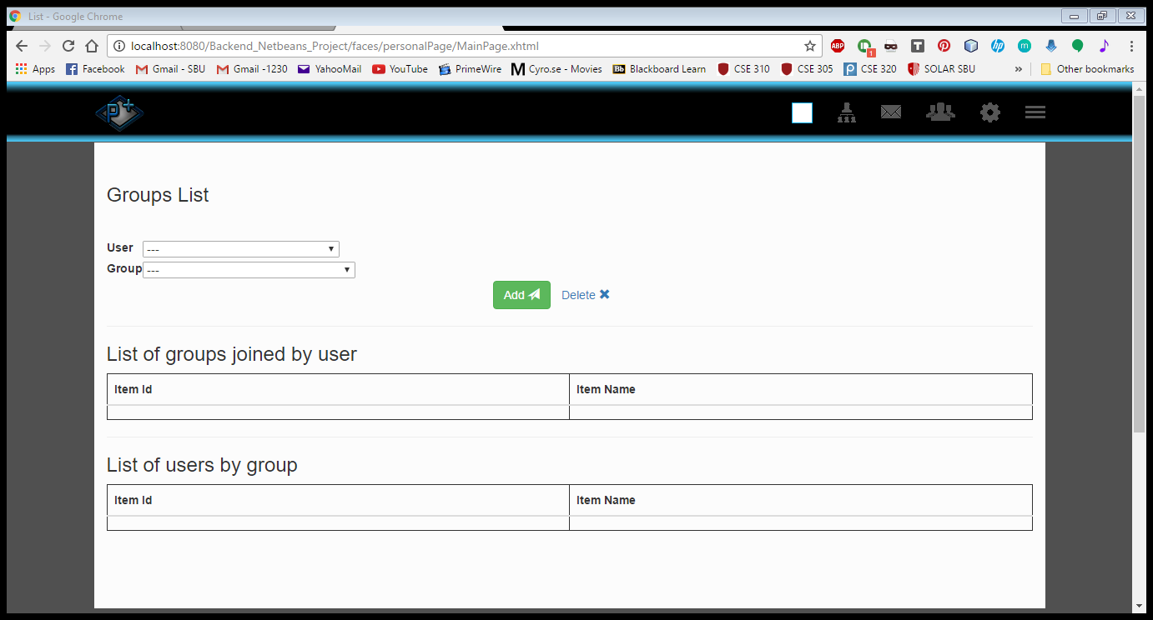

* + Make a post

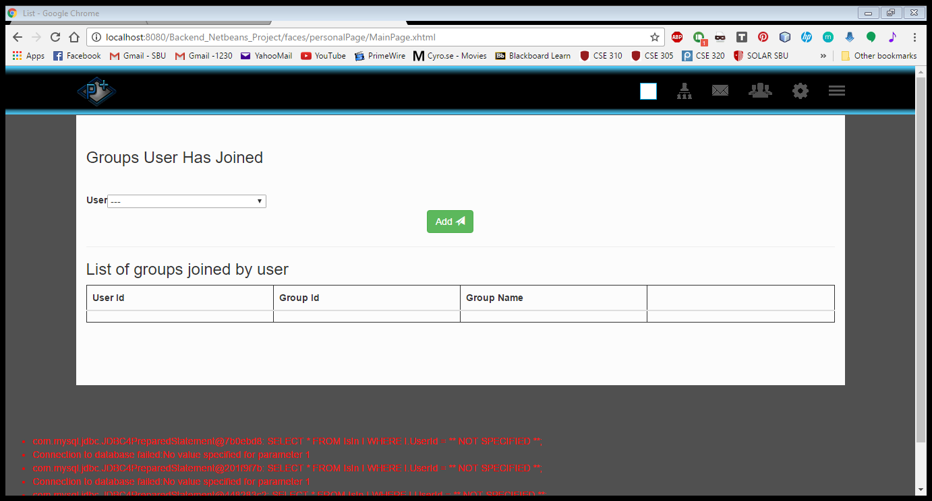

* + Comment on a post

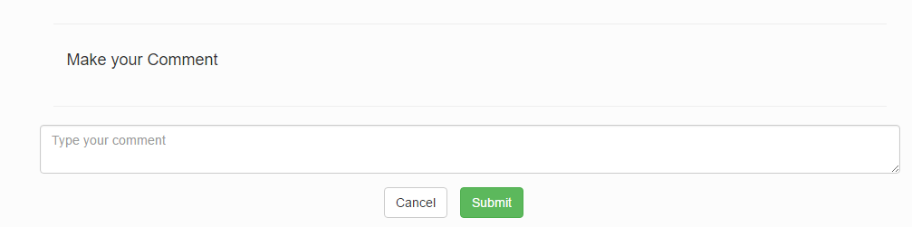

* + Like a post

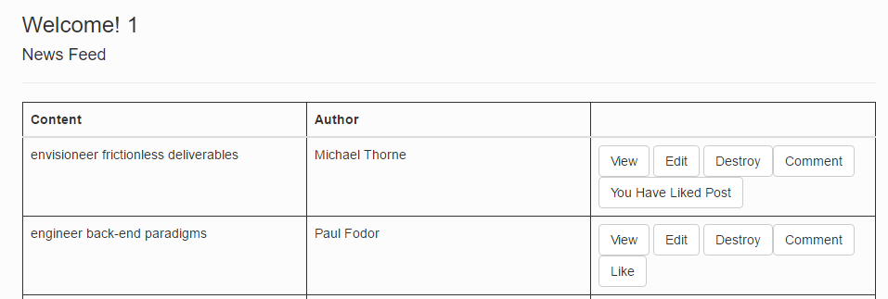

* + Like a comment

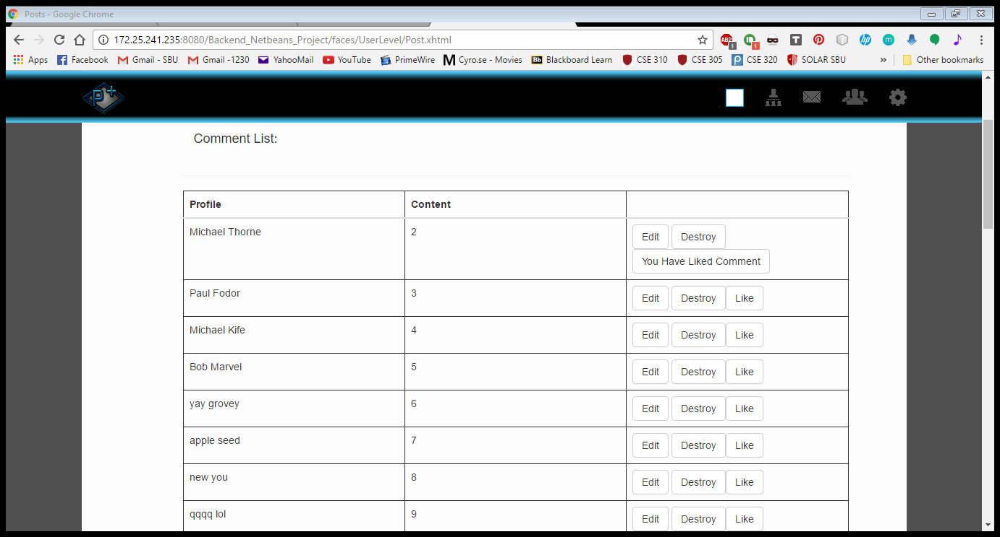

* + Remove a user from a group

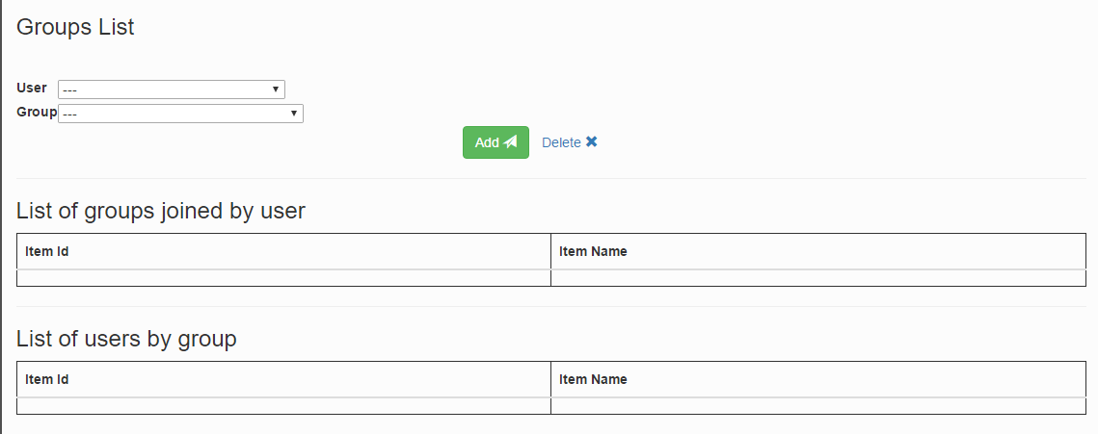

* + Remove a post, Unlike a post,



* + Remove a comment, Unlike a comment



* + Modify a post

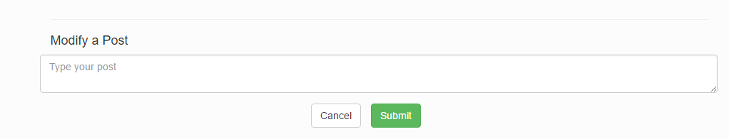

* + Modify a comment

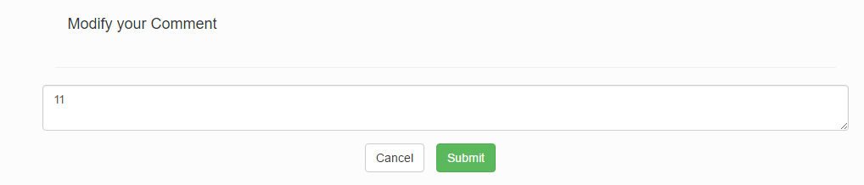

* + Delete a group

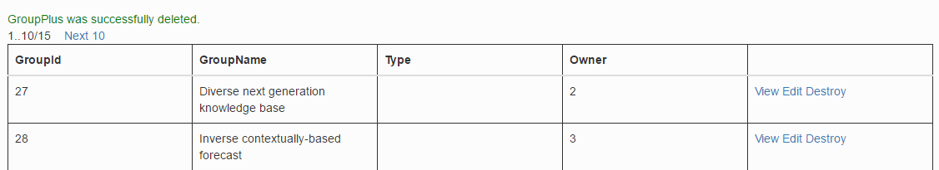

* + Rename a group

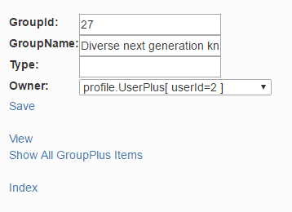

* + Make a post on a group page

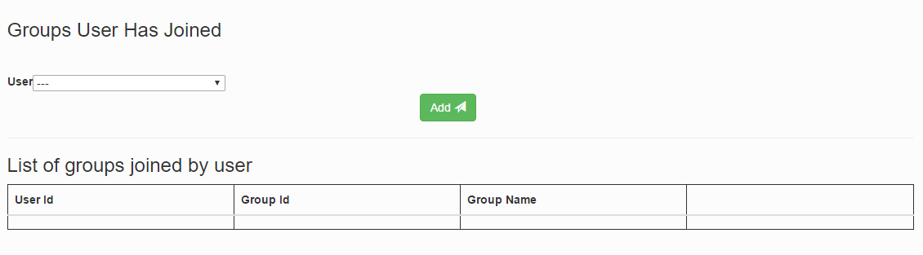

* + Comment on a post on a group page

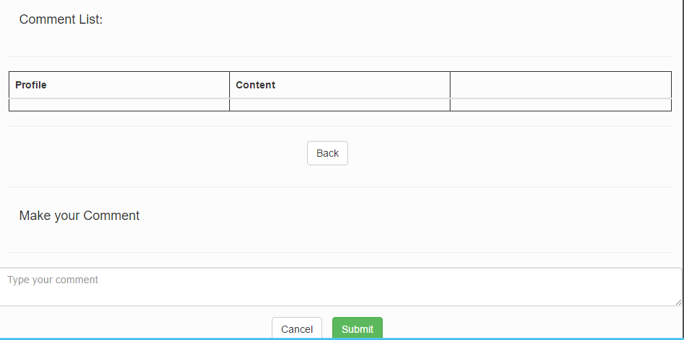

* + Like a post on a group page, Unlike a post



* + Remove one of their posts on a group page



* + Remove a comment, Like a comment on a group page, Unlike a comment



* + Modify a post



* + Modify a comment



**Manager-Level Transactions:**

* + Add, Edit and Delete information for an employee

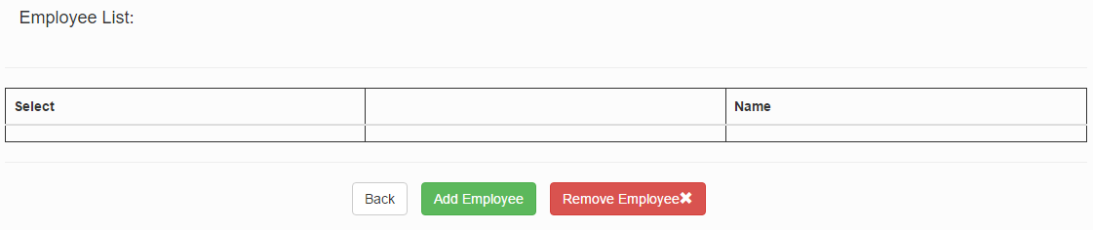

* + Obtain a sales report for a particular month

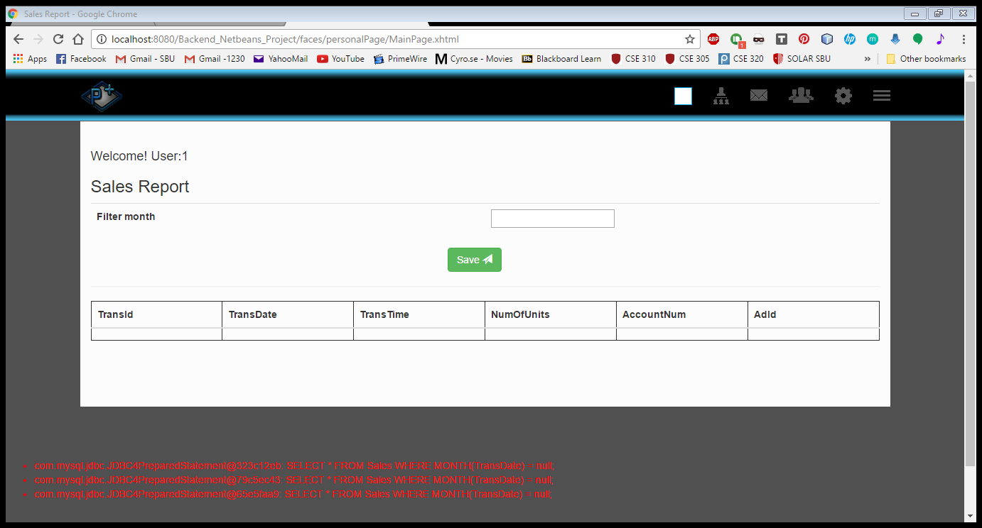

* + Produce a comprehensive listing of all items being advertised on the site

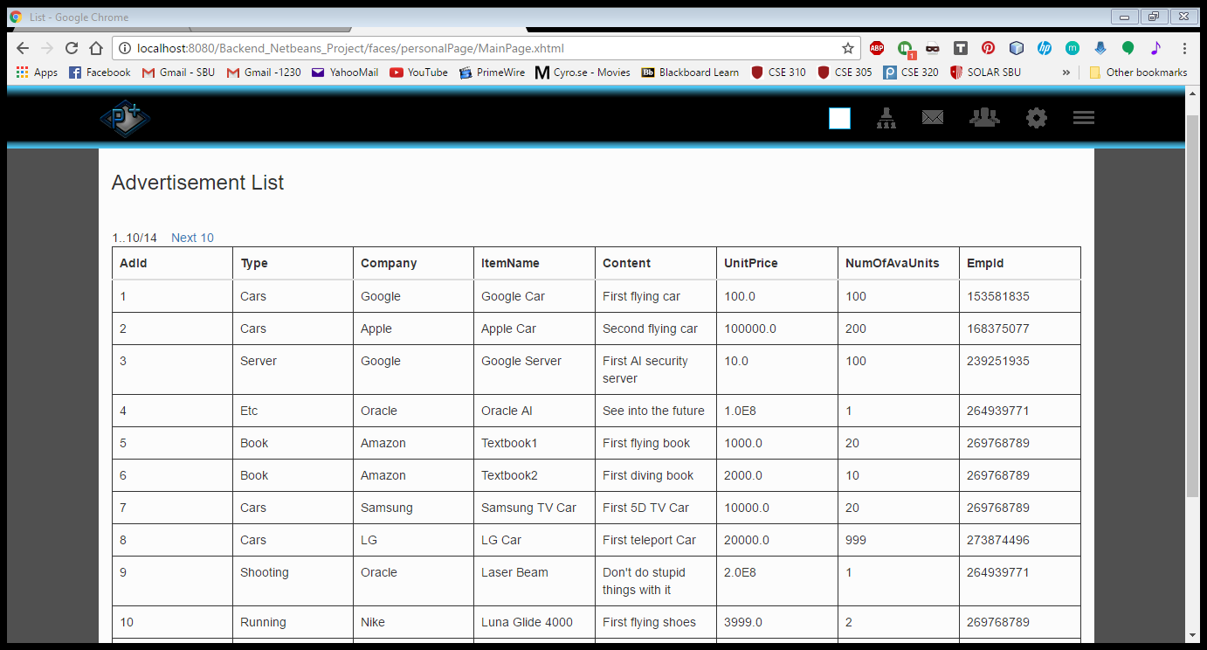

* + Produce a list of transactions by item name or by user name

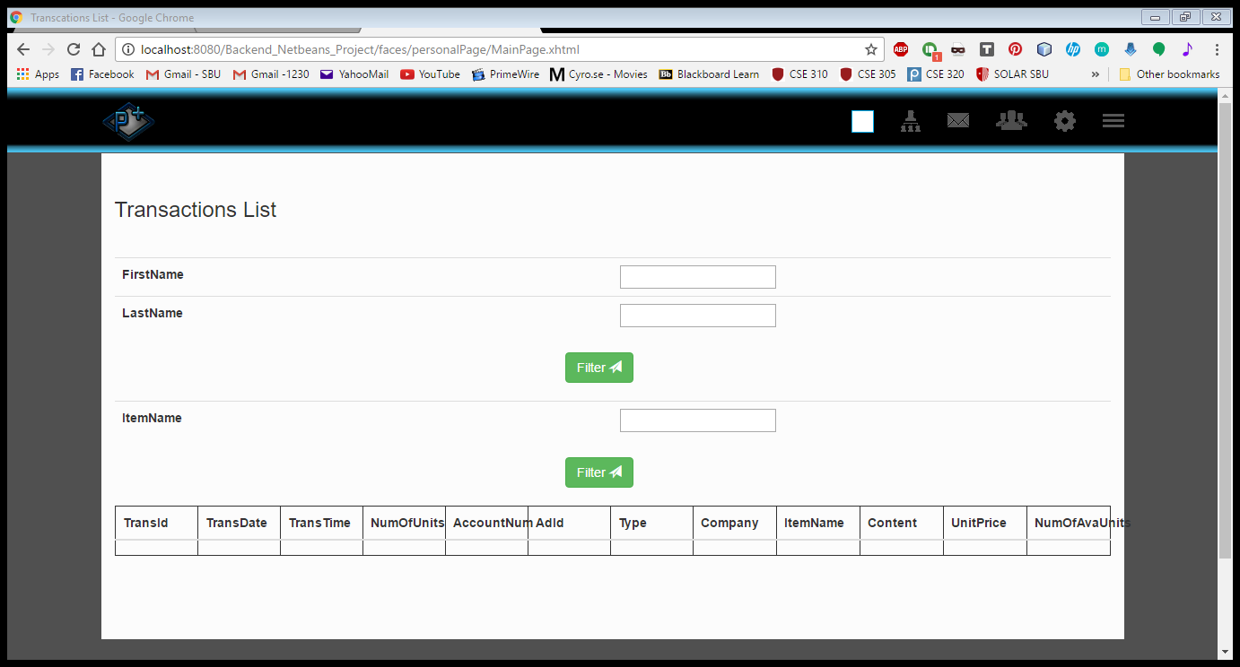

* + Produce a summary listing of revenue generated by a particular item, item type, or customer

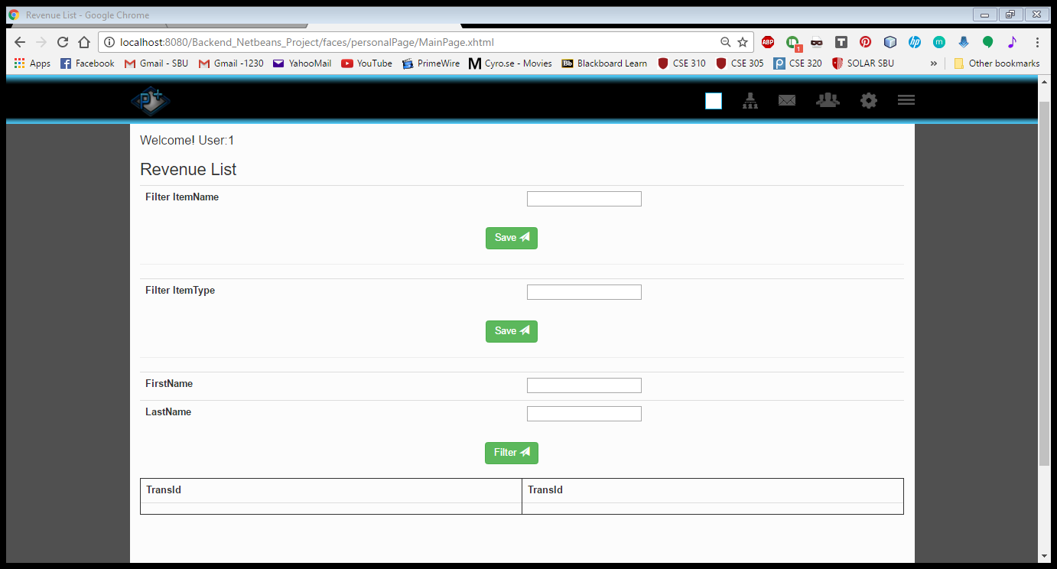

* + Determine which customer representative generated most total revenue

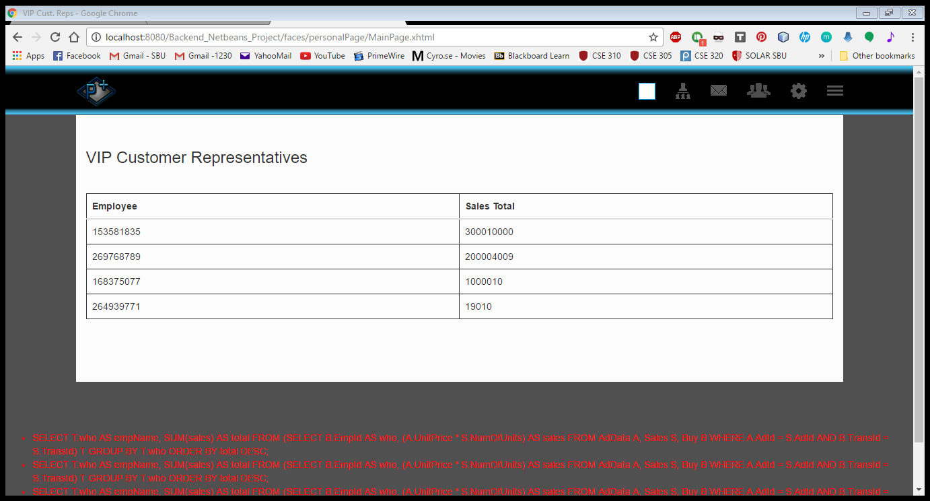

* + Determine which customer generated most total revenue

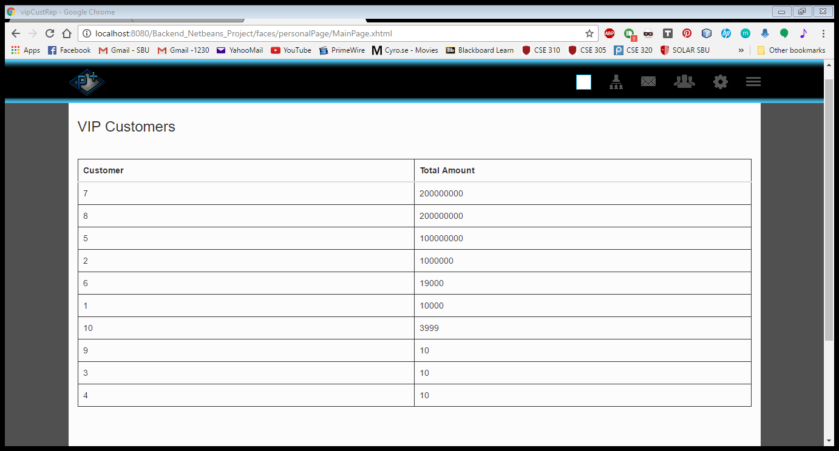

* + Produce a list of most active items

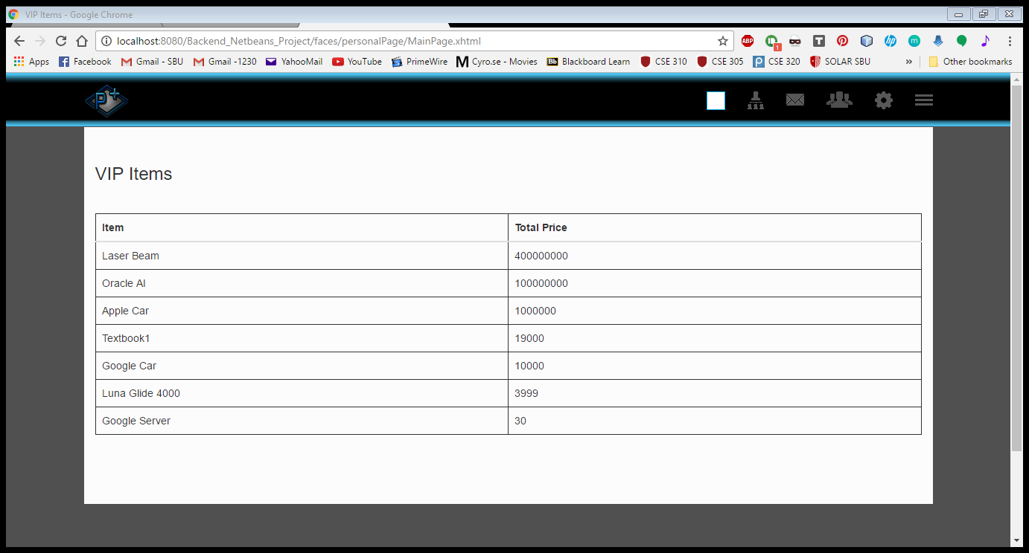

* + Produce a list of all customers who have purchased a particular item

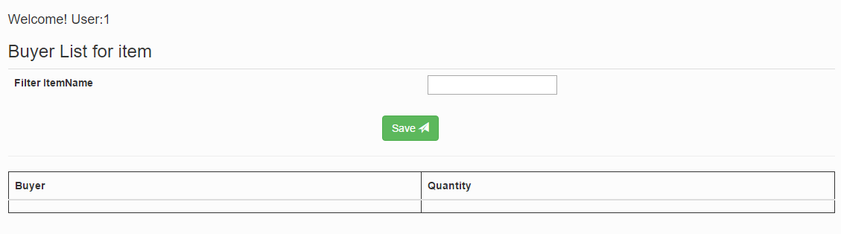

* + Produce a list of all items for a given company

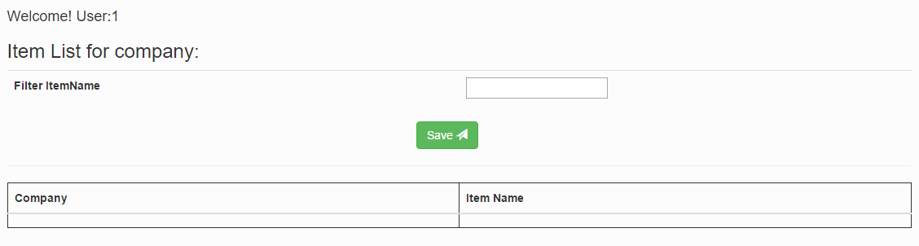

**Customer-Representative-Level Transactions:**

* + Create an advertisement

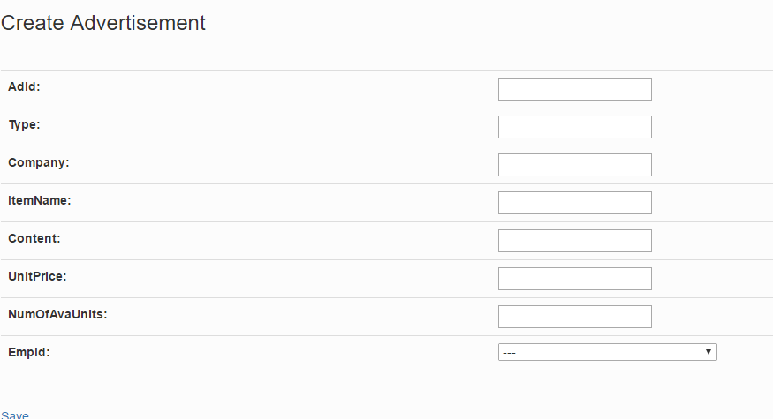

* + Delete an advertisement

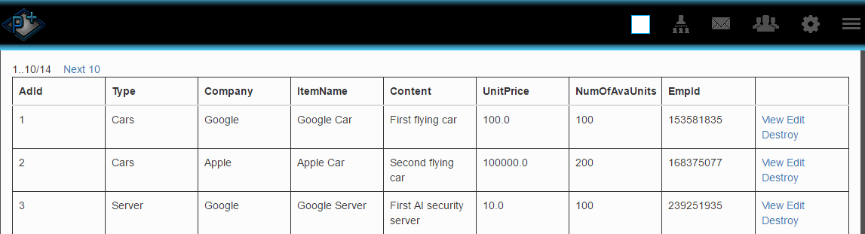

* + Record a transaction

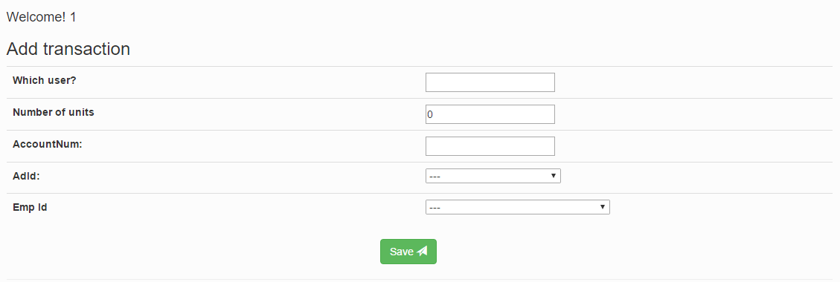

* + Add, Edit and Delete information for a customer

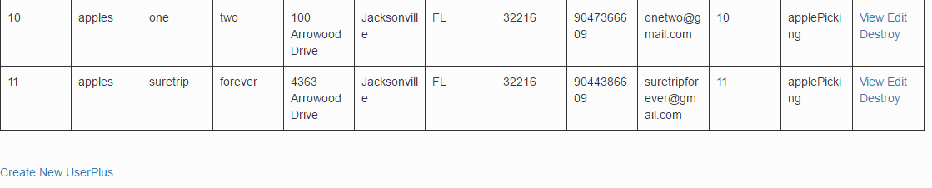

* + Produce customer mailing lists

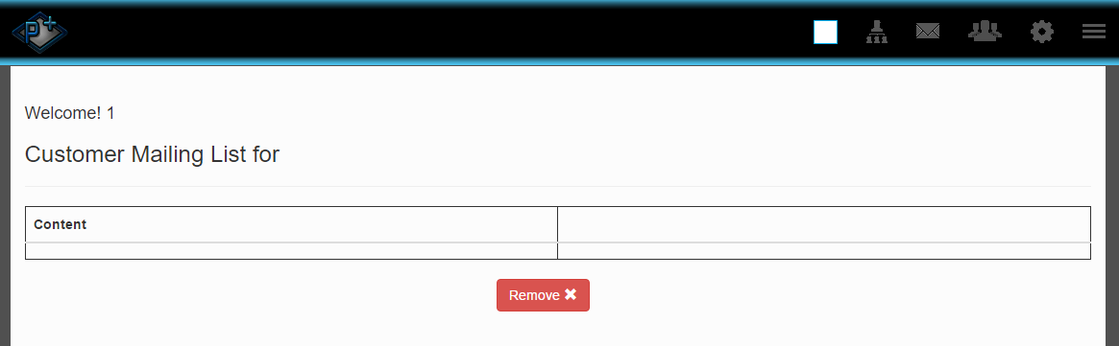

* + Produce a list of item suggestions for a given customer (based on that customer's past transactions)

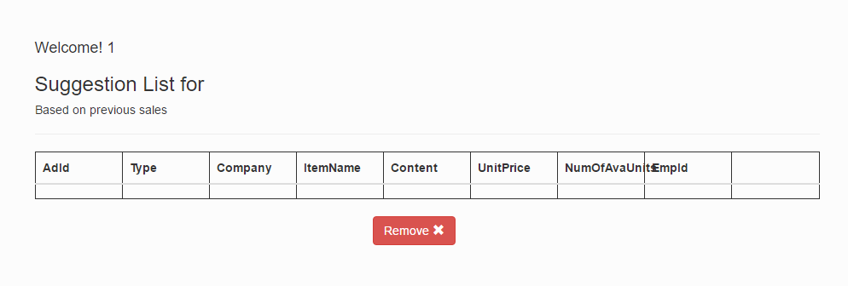

* + Retrieve a customer's current groups

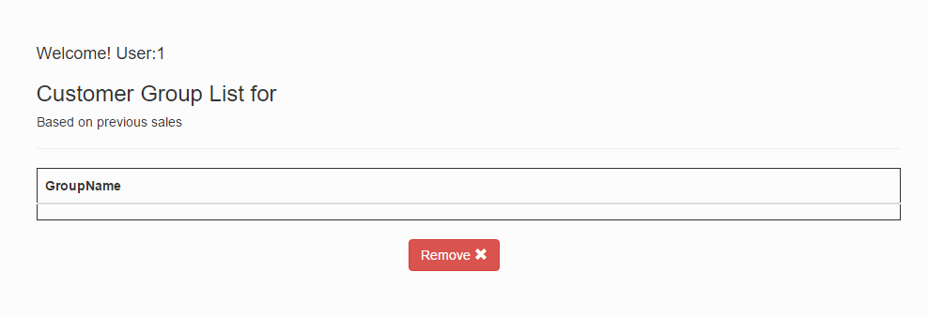

* + For each of a customer's accounts, the account history

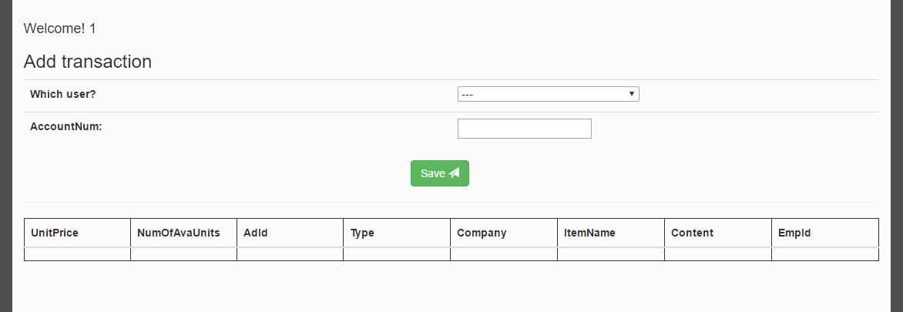

* + Best-Seller list of items

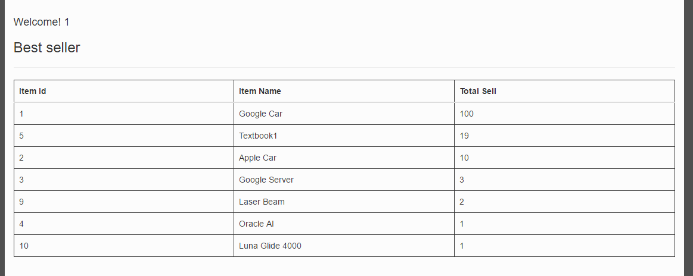

* + Personalized item suggestion list

